Notion
Github

Ideation
Potential Ideas:
Study planning app
- Help students schedule what to study and when to study.
- Would be immediately useful to myself and students alike.
- Pre-defined selection of various subjects + Ability to name and add your own subjects.
- Drag and drop subjects into spaces on a calendar-like interface.
- Able to assign notes to planned subjects
- The problem is that there is already a large selection of free study planners that can be found online.

Computer vision
- Track a facial feature to control the sound of your guitar playing.
- Allows the use of a guitar pedal without your foot (which is how it’s usually controlled)
- Helpful for guitarists that don’t have a pedal or are unable to control one with their legs.
- Ability to calibrate the tracking according to the user’s facial features.
- Have not seen a similar idea online yet.

Game development
- Create a unique game
- Have it be educational
- Simple, easy to understand UI
- Very generic idea, not very interesting.

Educational crypto investment app
- App to help students learn how investments work in Bitcoin, Ethereum, and other cryptocurrencies change over time without risk of losing money.
- Uses an API to fetch real time stock data.
- Able to invest fake money.
- Able to see and compare investment values from various times.
- Although websites/apps that do this already exist, the market is not that large.

I have decided to do the computer vision guitar pedal project.

Specifications
The “wah” pedal is a guitar pedal that is usually only controlled using your feet. My outcome allows users who don’t own the pedal (or for any reason are unable to operate one) to control the pedal using just their mouth. Opening the mouth will cause the wah to open, and closing it will cause it to close.
It will be able to work with any guitar plugin since MIDI messages are universal. I will do my testing with a plugin named ToneLib-GFX inside of Reaper(the digital audio workstation I use).

Specifications for computer vision guitar pedal project:
- Able to track landmarks on the face mesh, specifically top and bottom lips.
- Able to send a MIDI CC(control change) signal to a guitar plugin.
- Able to translate the distance between the top and bottom lips into a MIDI CC value from 0 to 127.
- Simple, modern looking GUI.
- Navigation bar on the bottom of the screen with a settings button, calibration button, and a homepage button.
- User can calibrate the mouth wideness to suit their preferences.
- User can drag a slider in the settings page to manually calibrate the mouth detection.
- Webapp changes layouts depending on the user’s screen size, so that the app is suitable for all devices.

Advanced Techniques:
- Media queries – The layout of the web app will change depending on what device is using it. Desktops with a wide, horizontal screen will have all of the pages side-by-side on one page. Whereas people using phones will be shown a navigation bar on the bottom leading to each page.
- JSON data files – Settings for the webapp will be saved in a JSON file so that they stay the same after closing the app. Each time the user changes a setting, it’s new value will be written to the JSON file.
- CSS Grid – Used to create identically sized buttons in the navigation bar which scale according to the screen width. Also used to display everything on one screen, side-by-side on a desktop screen.

Additional Research
Sending MIDI from Python
- There are a few ways to do this that I discovered during my research.
  - Mido in combination with python-rtmidi
  - With only python-rtmidi
  - Pygame’s built in MIDI function
- Mido still uses python-rtmidi, it just acts as a wrapper to make python-rtmidi easier to work with. This and Pygame MIDI are the simplest to use, but Pygame is less suited for my use case because it is primarily for game windows. So, I will use Mido and python-rtmidi to send MIDI signals to my guitar plugin.

Creating the Web App
Things that I could use are:
- Streamlit
  - Simple to use.
  - Clean UI.
  - Does not handle real time operations very well, which is a deal breaker for my use case.
  - Does not support media queries.

- HTML and CSS
  - Complete control over the loop of the web app, more complex.
  - Need a Python backend framework to allow the script to communitcate with the web app.
  - Handles real time operations.
  - Supports media queries.

- NiceGUI
  - Not too complex.
  - Will be able to handle real time operations.
  - Supports media queries.
  - Clean UI.

NiceGUI suits my needs so it is the one I will use to create the webapp

Logs
15/06/2026 - Setting up Mediapipe for face-tracking:
- I will be using Mediapipe tasks with the face landmarker model to allow the tracking of the lips.
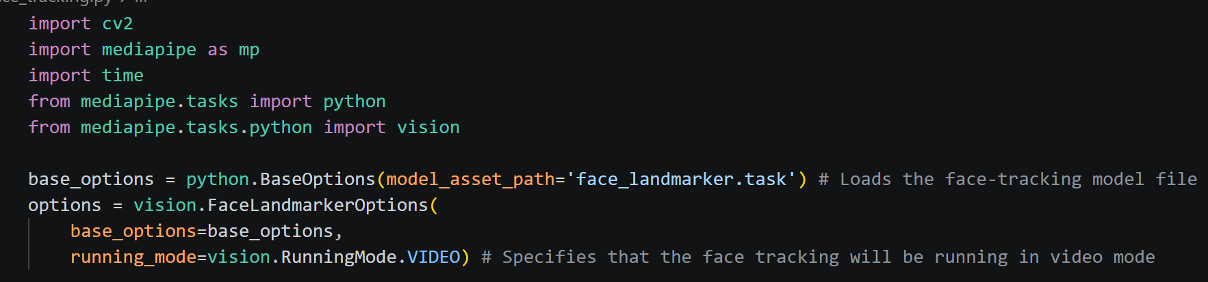
- Set up camera:
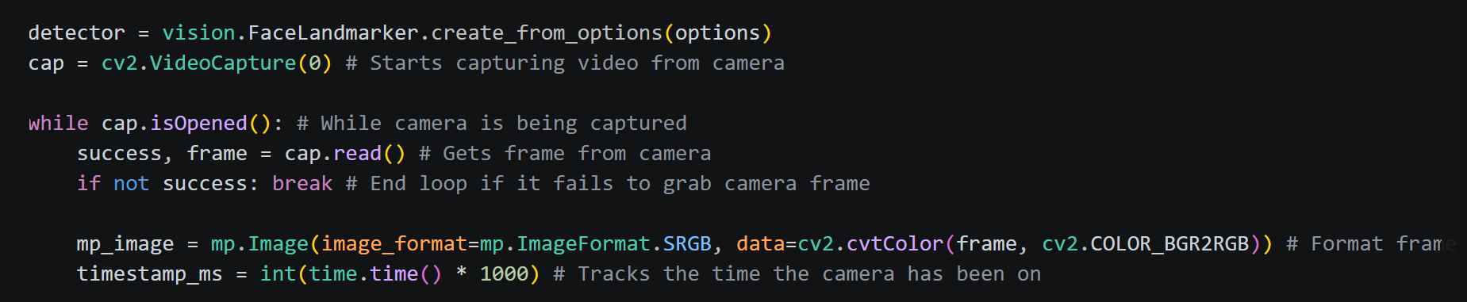
- Take the positions of the top and bottom lips:
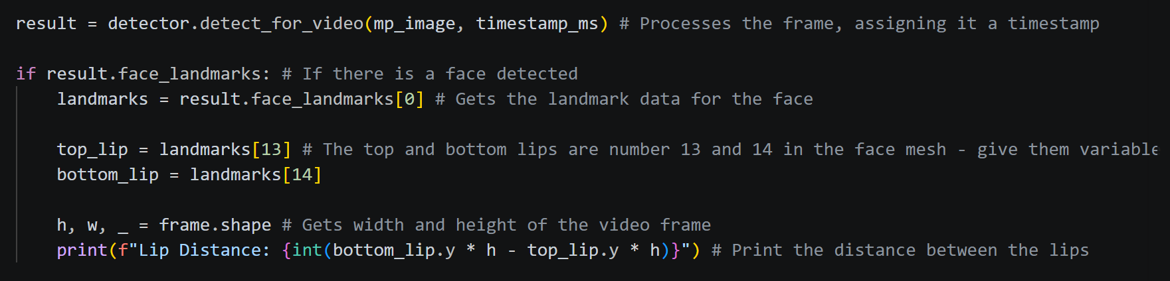

16/06/2026 - Learning how to send MIDI commands from python:
- There are a few ways to do this that I discovered during my research.
  - Mido in combination with python-rtmidi
  - Just with python-rtmidi
  - Pygame’s built in MIDI function

- Mido still uses python-rtmidi, it just acts as a wrapper to make python-rtmidi easier to work with. This and Pygame MIDI are the simplest to use, but Pygame is less suited for my use case because it is primarily for game windows. So, I will use Mido and python-rtmidi to send MIDI signals to my guitar plugin.
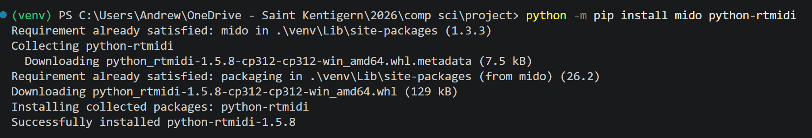

- Reaper(the audio software I’m using) cannot receive MIDI signals straight from Python, it has to pass through a virtual MIDI cable first. For the virtual MIDI cable, I will be using loopMIDI.
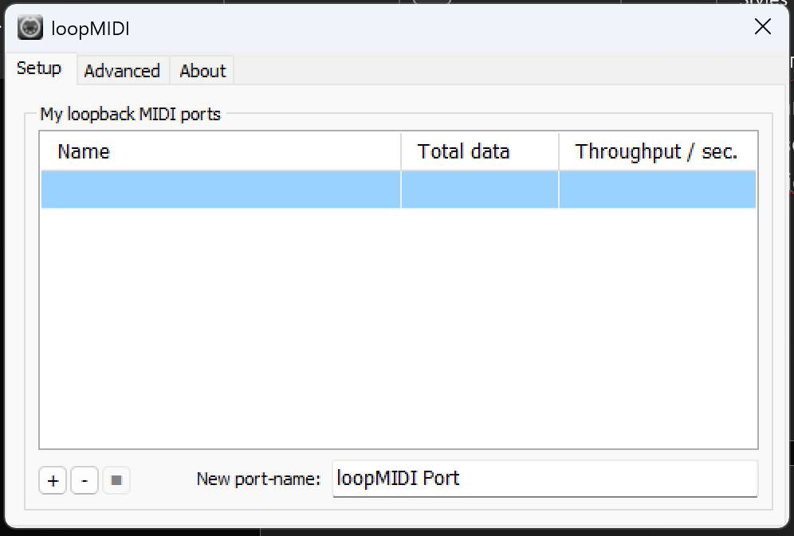

- Code to test that python can send signals through the virtual MIDI cable.
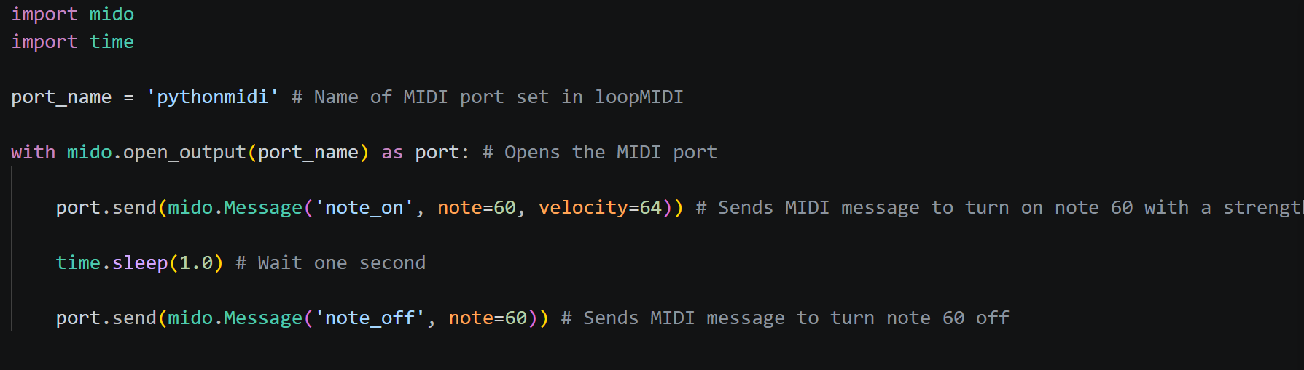
- Issue:
Having an issue where it says there is no port named ‘pythonmidi’ even though it is exactly what I named the virtual MIDI cable.
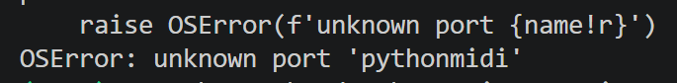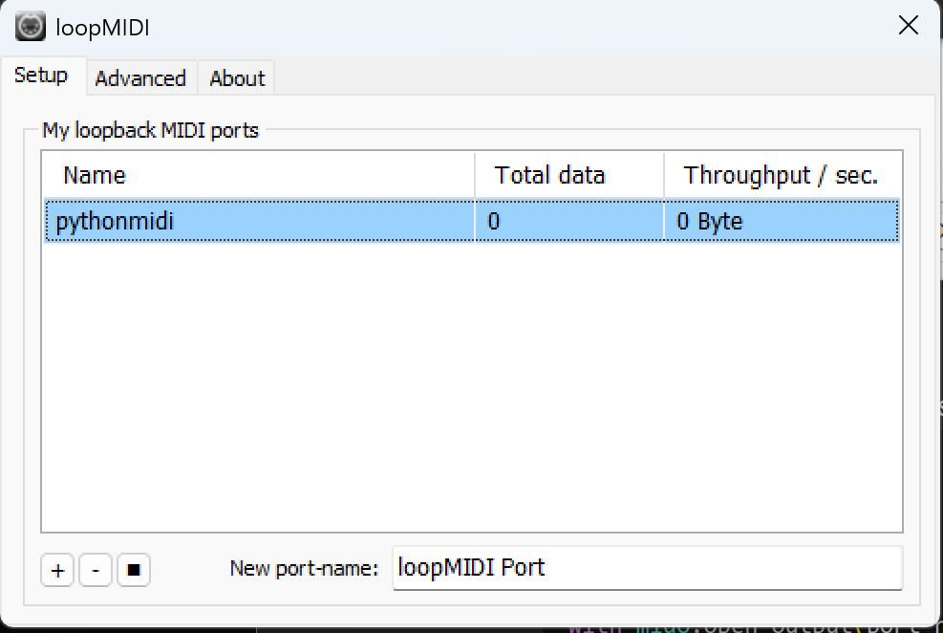
- Got Mido to the name of every open MIDI port on my laptop. And it turns out that the port is actually named ‘pythonmidi 1’
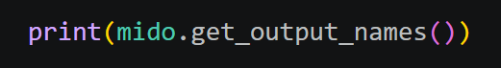

- Fixed the code and now it does send the MIDI signal.
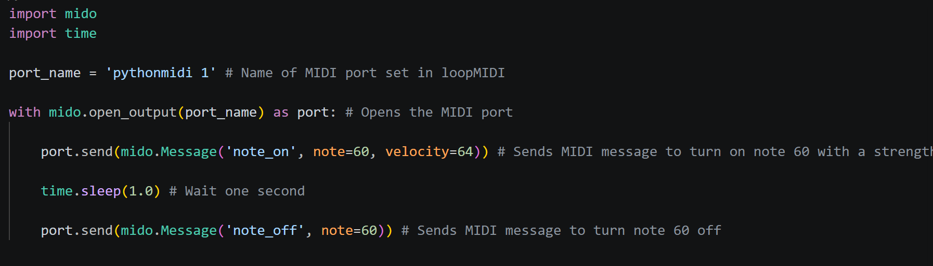

- Picture showing loopMIDI detecting the MIDI messages being sent through the virtual MIDI port:
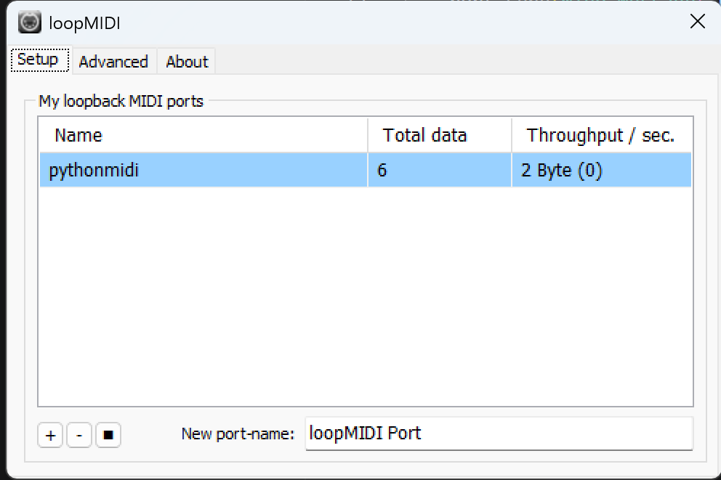

18/06/2026 – Continuing with Python MIDI
- Modifying test code to send MIDI CC (control change) messages:
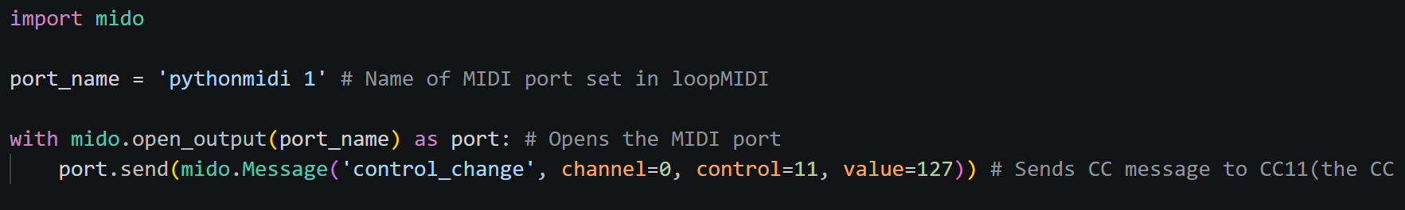

- Working on having Reaper(my guitar software) receive the MIDI signals so that I can control a parameter inside the guitar plugin from Python.

- Issue:
The guitar plugin should automatically detect the message and map it to the pedal I have chosen, however, it is not detecting it.
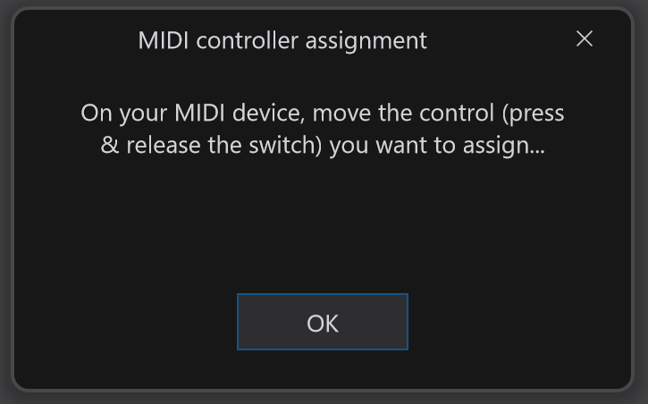

- I missed a whole setup step inside of Reaper, which was most likely why the plugin wasn’t detecting the MIDI messages.
- Enabling the MIDI input:
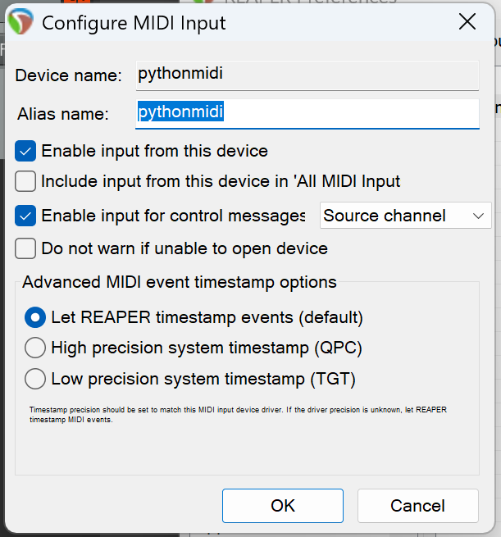
- Routing the MIDI signal to the guitar track: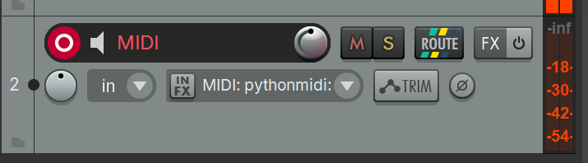
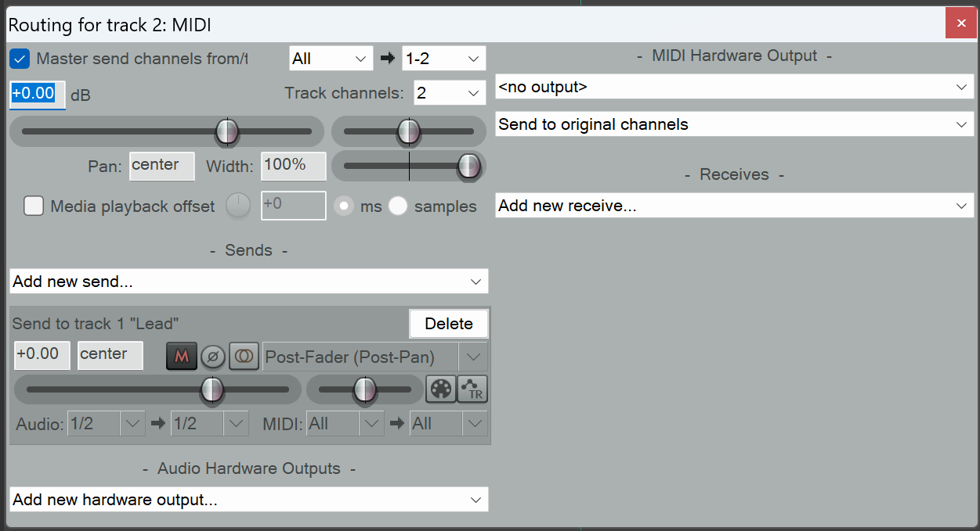

- After going through these steps to set up MIDI inside of Reaper, the MIDI message can now be received by the guitar plugin
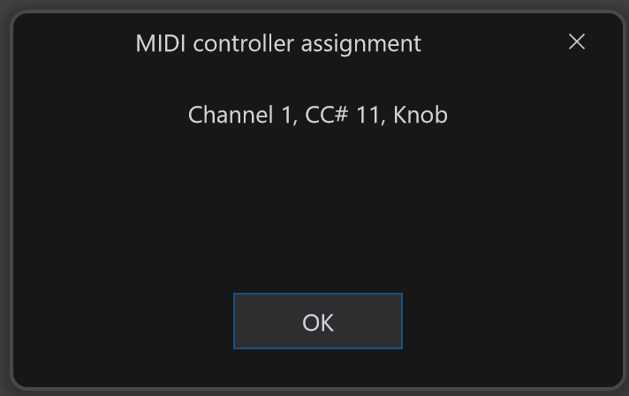
- Because the ‘value’ function inside the send MIDI message line is set to 127, it will max out the pedal position. Changing the value from 0 to 127 will change the pedal position accordingly.
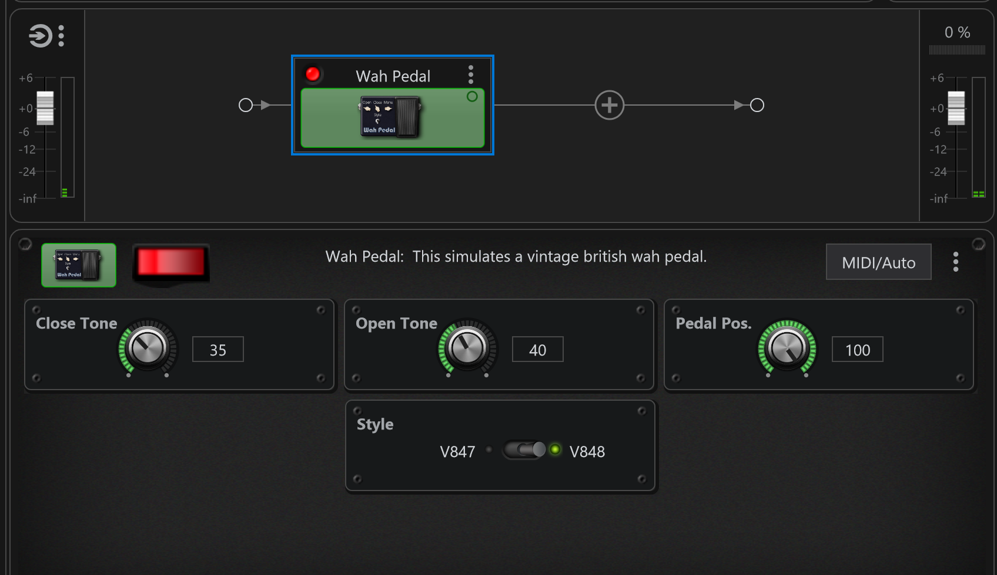

22/06/2026 – Continuing to work on the face tracking
- Duplicated the Python file with mediapipe, I will use the new file to incorporate Mido into the face tracking code.

- Trying to turn the distance between the user’s lips into a percentage so that it is easier to convert into a CC value of 0 to 127 later.
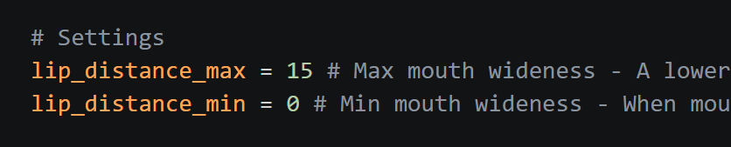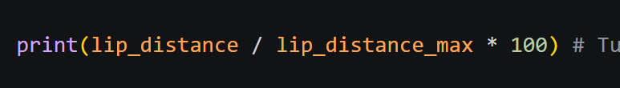

- Issue:
Current code only finds the percentage out of the max lip distance. It goes over 100 percent if I open my mouth wider, and it is not affected by the minimum lip distance. So it’s not very helpful.
I need it to turn the distance into a percentage out of the max and minimum lip distances.
Found this formula on Stack Overflow:
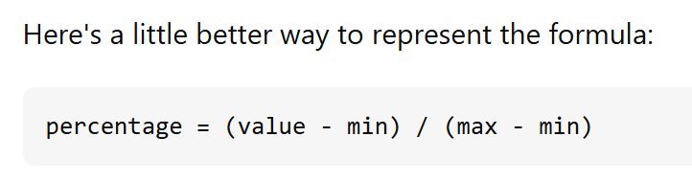
Implemented the formula into my code:
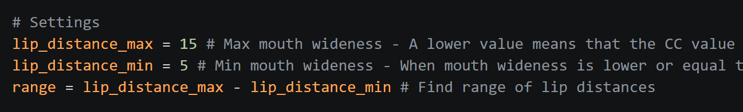
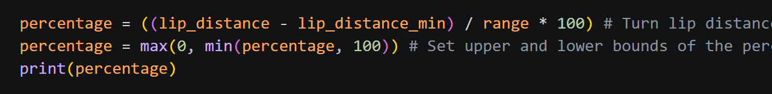
Now the distance between the lips is printed as a percentage of the range from 0 to 100.

25/06/2026
- Make Mido send CC message according to the mouth wideness percentage.
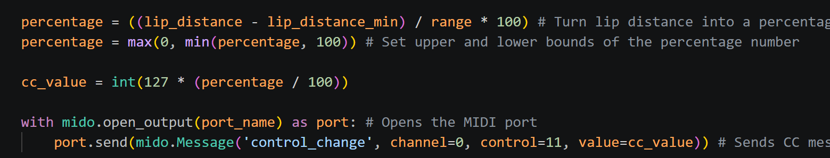

- Wah pedal position now changes when you open or close your mouth
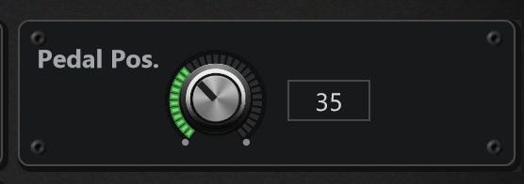

25/06/2026 - Beginning work on the UI
- I will make the mobile layout first.

- Made a navigation bar on the bottom of the screen.
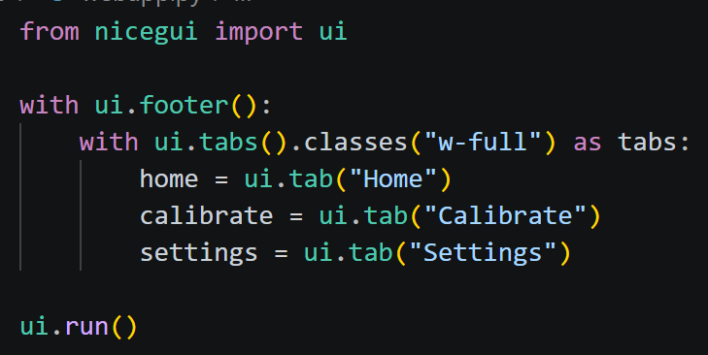
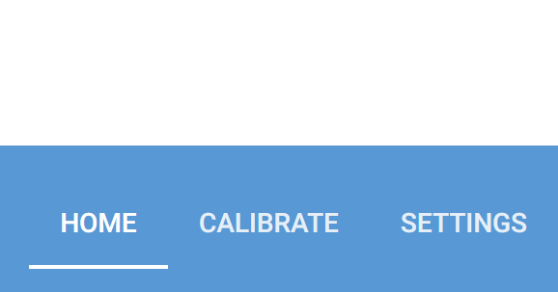

- Using ui.tabs doesn’t quite give me the look I want, I’m going to switch to using buttons so I can have more control over how they look.
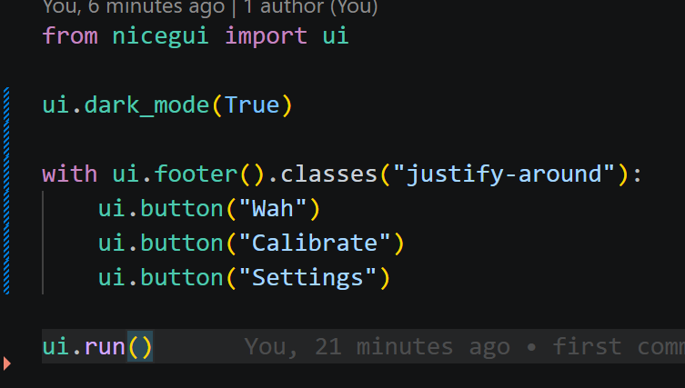

- Utilising flexbox grid to get buttons to fill up the navigation bar
https://tailwindcss.com/docs/grid-column

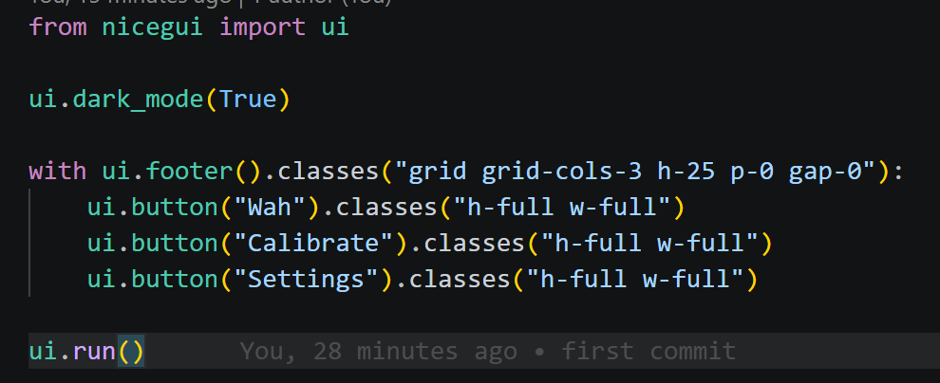
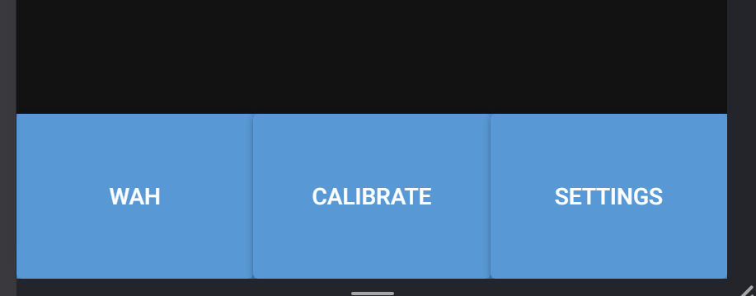

3/07/2026 – Finalising the basic UI layout
- Picked a color scheme and changed the background color:
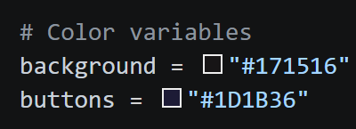
- Styled the buttons – removed drop shadow, changed the color, rounded only the top right and left button corners.
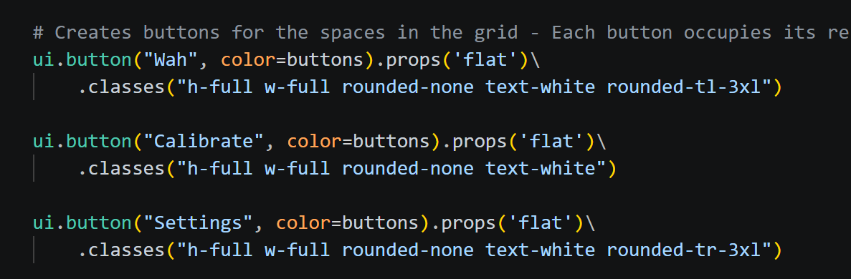
- The navigation bar now looks like this:
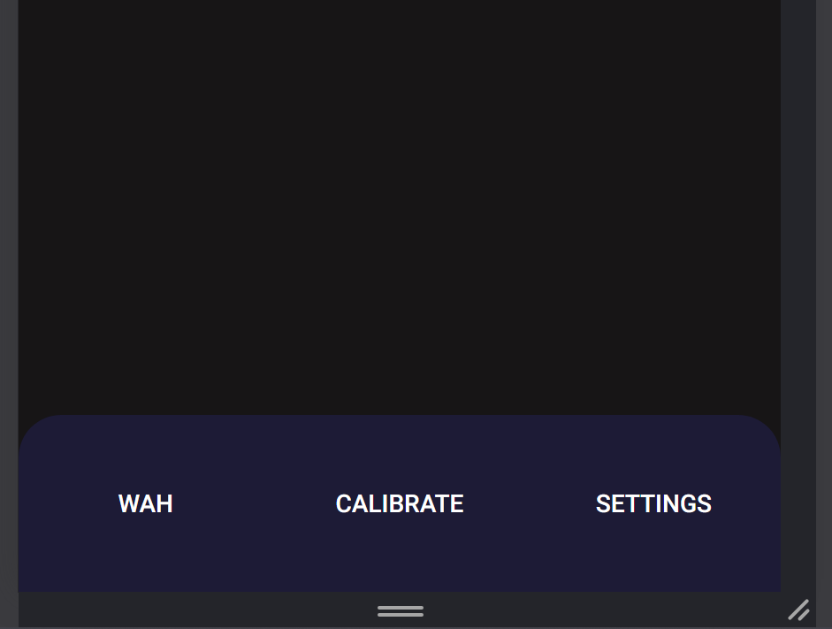

- The bar icons have not been finished yet so I have not added them to the nav bar.

2/07/2026 – Beginning to create the individual pages
- I believe it would be best that I use one page for all the functions rather than a separate page for each. This means that my app wouldn’t have to load a complete new webpage, and it will hopefully run smoothest.
- I can do this by creating a container to show the content, then clearing it and then showing new content when another tab is selected.

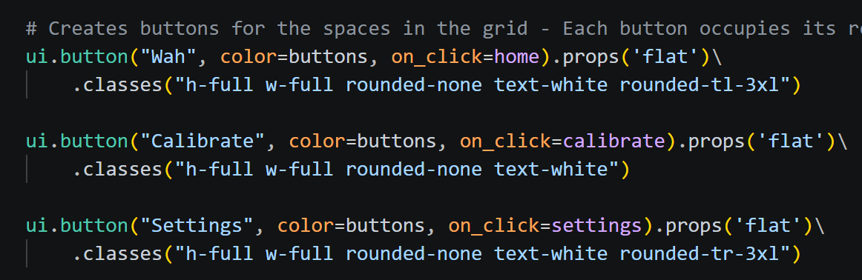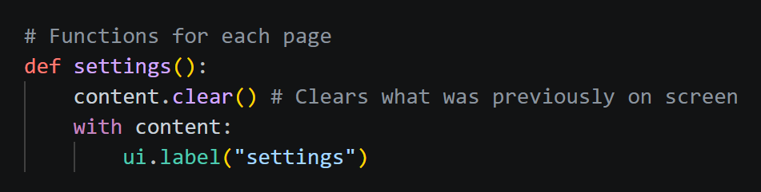

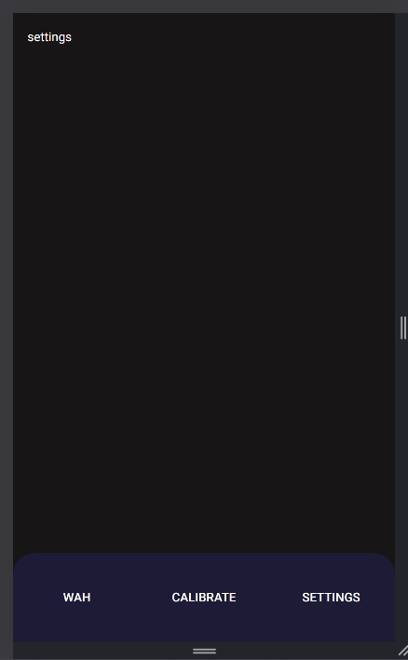
- Clicking on each button in the nav bar will cause the text to change accordingly. I will create UI for each tab in their respective function shown above.

29/07/2026 – Working on the main page
- I’m not sure how I should create the gauge I want. It should be a semi-circular bar that updates depending on the percent of the wah, however, the built-in displays such as ui.highchart and ui.echart don’t look how I want them to look.
- Making it a semi-circle was too difficult for me, I’m going to use a full circle for the status bar to make it manageable.
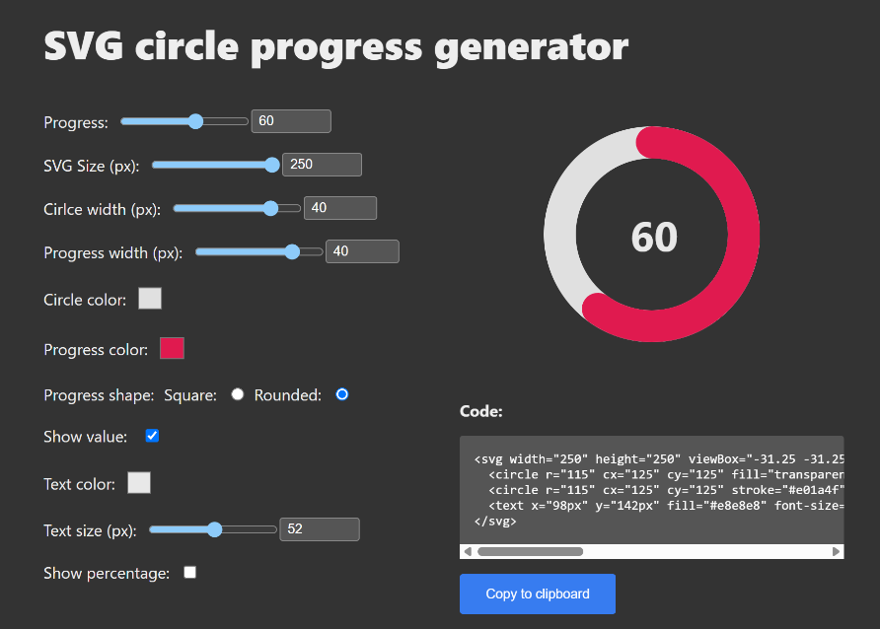
- I will use this website to generate a gauge: https://nikitahl.github.io/svg-circle-progress-generator/

- Testing it separately, and trying to update the value in real time.
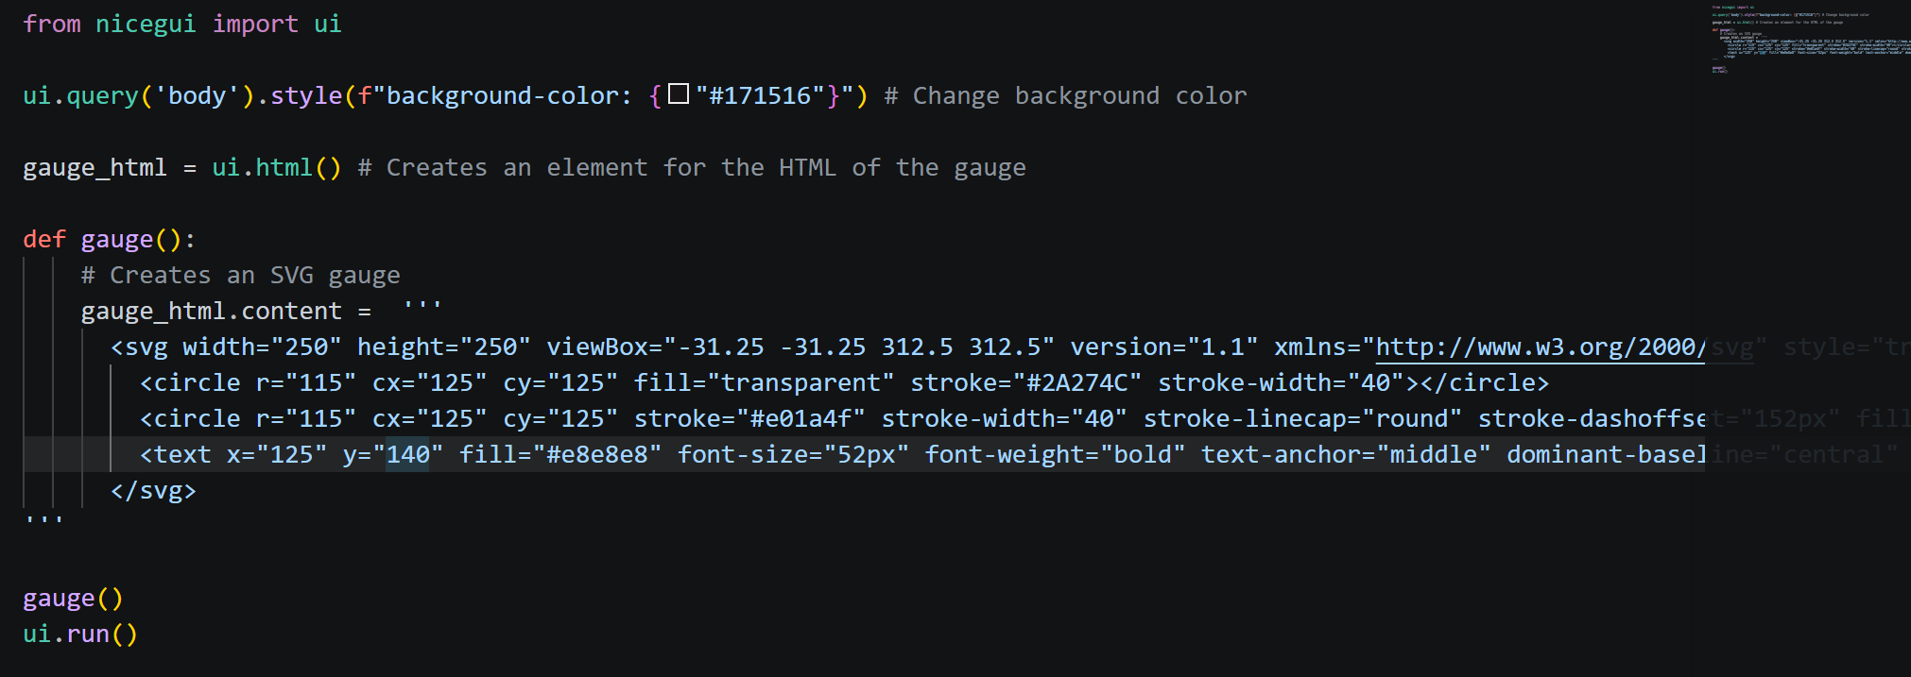
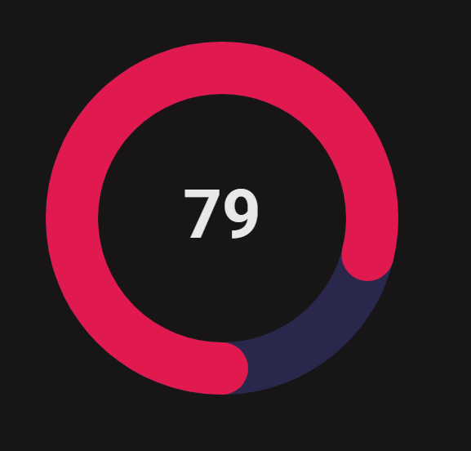

- The lines that control the value of the gauge are “stroke-dashoffset”, the line that displays the value in the middle of the gauge.
- Stroke-dashoffset has a range of 0 to 722, so I will need to make sure a value of 100 corresponds to 722.
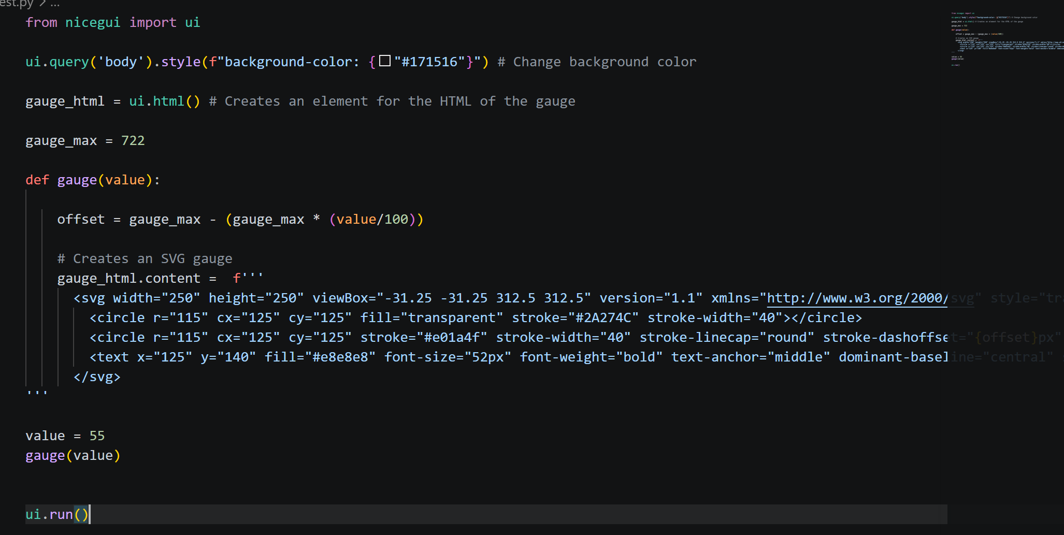
- Gauge now updates according to the value variable.

5/08/2026 – Adding the gauge onto the actual UI
Since the line of code to create the element for the gauge is inside the homepage function, the gauge function (which is outside) can’t access it. I fixed this by adding an extra parameter in the gauge function.
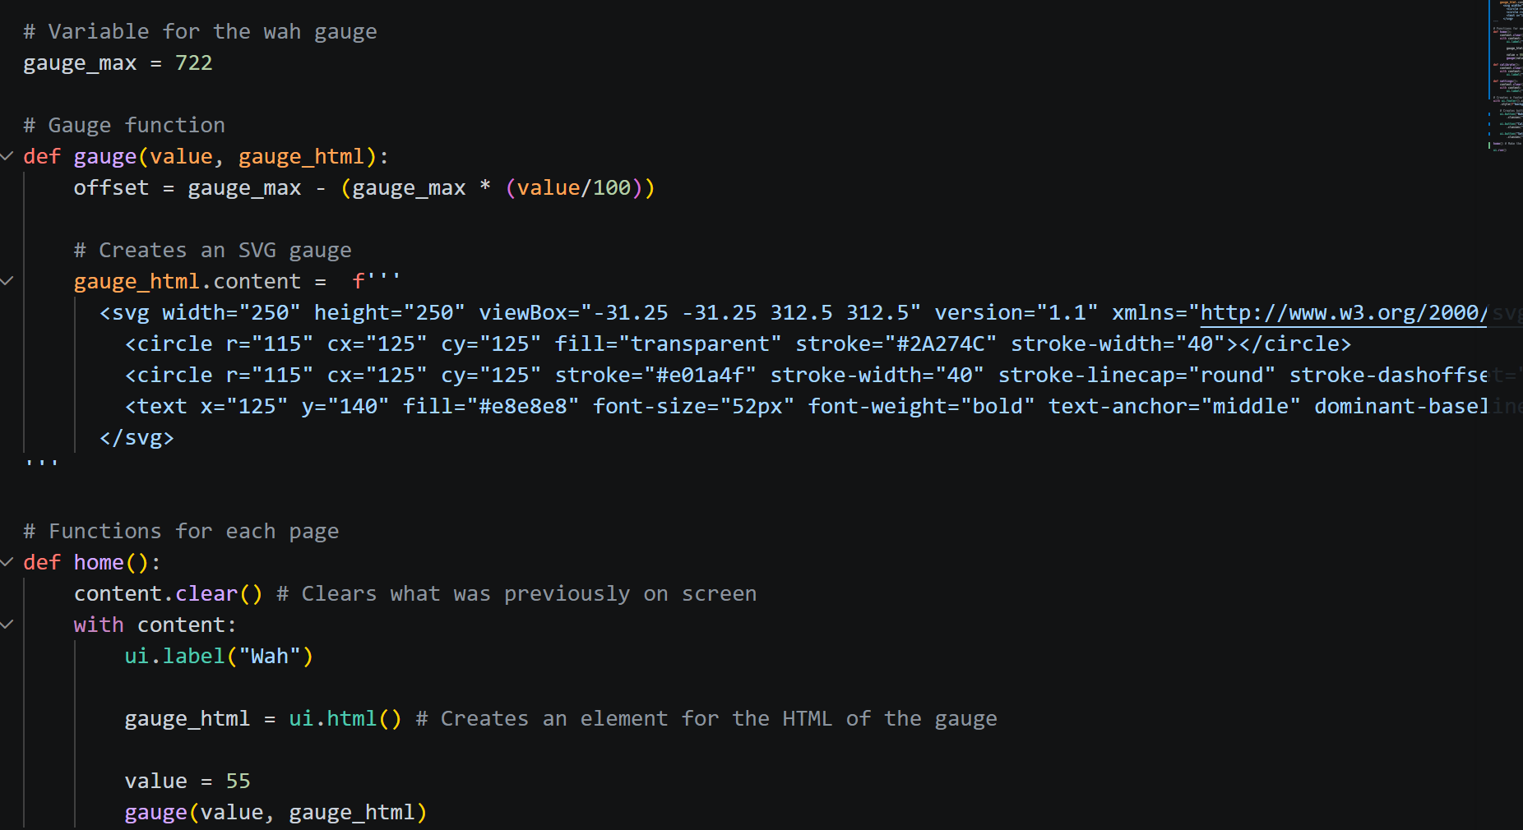

- Created a proper header
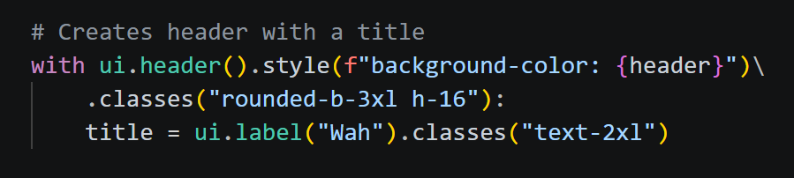
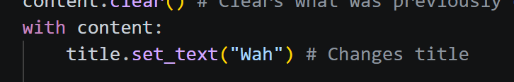
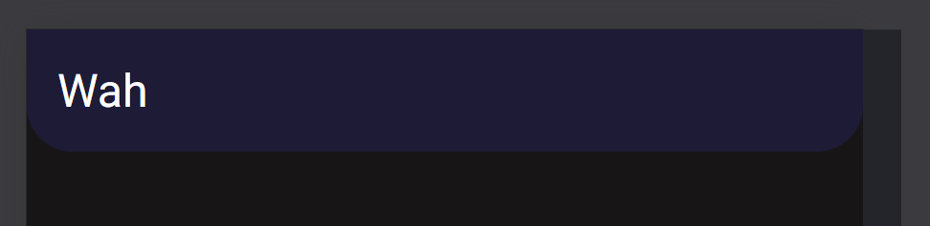
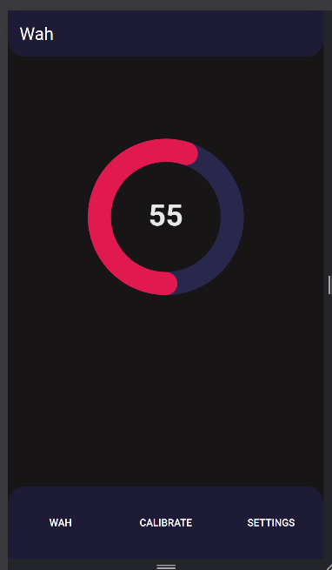
- The home page of the webapp now looks like this:

6/08/2026 – Working on the settings page
- Added sliders for the settings using the example shown in the NiceGUI documentation
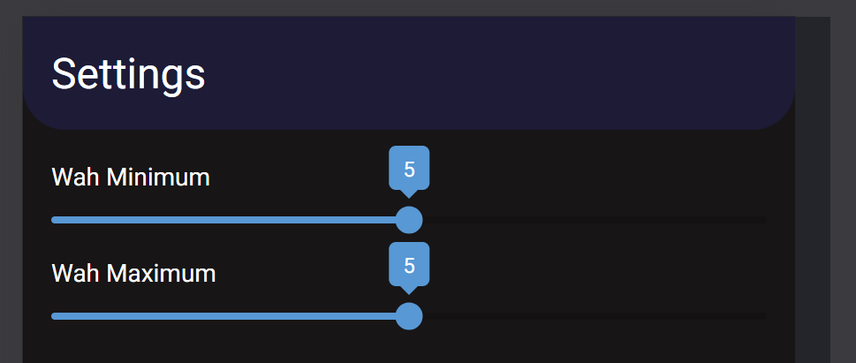
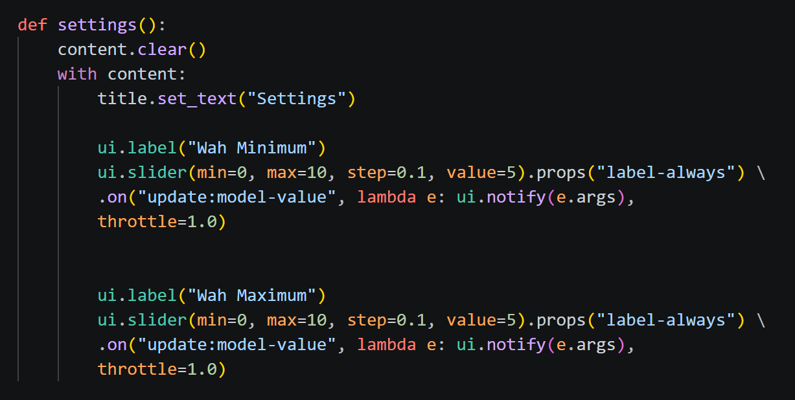
- These sliders currently do not do anything so I will make them save their values to a JSON file.
- I have created a function to update the JSON file but I’m unsure how to save the slider number.

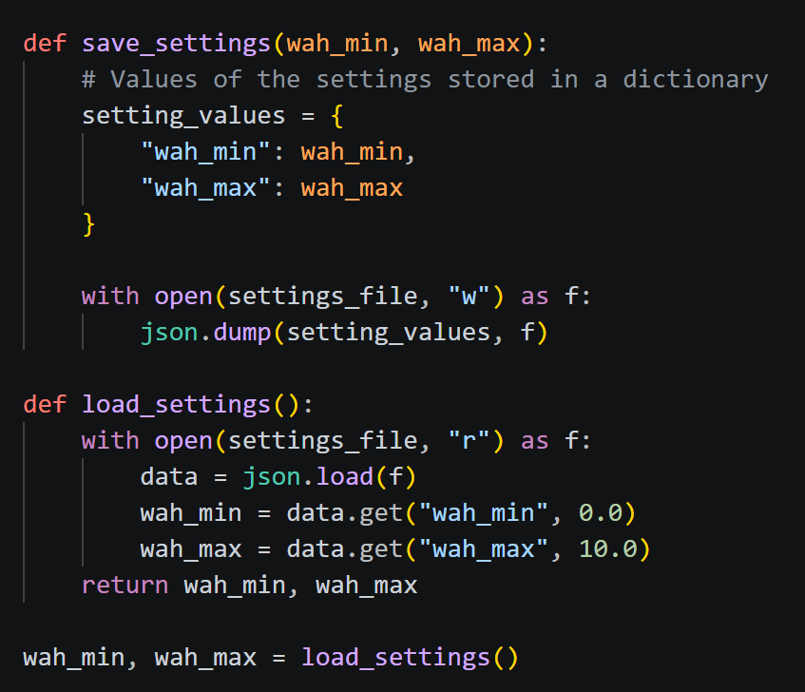

- I’ve encountered an issue with my variable for min and max wah being immutable, this means that I won’t be able to update it real time with my slider, so the wah settings wouldn’t actually change.
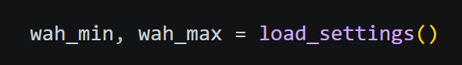
- To fix this, I’m using a dictionary to store the values because a dictionary is mutable.
- Starting by changing the function that loads the setting values
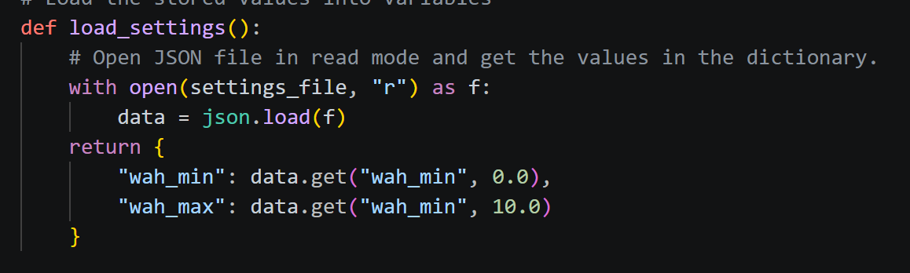
- Now it returns a dictionary instead of a tuple

7/08/2026
- Working on getting the value of the slider in real time
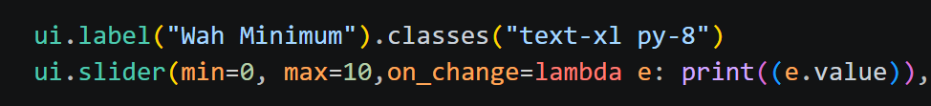
- I realised that it prints the updated value very frequently, while I only need it to update when the user releases the slider. I have to change it or else it might introduce unnecessary lag while changing the settings because of all the updates that are being done to the settings.

10/08/2026
- I’m finding it hard to make the settings without the actual wah program code, so I will put the settings menu on hold for now to combine the webapp with the wah.
- I’m told by google that I will need to utilise threading since the while look for the face tracking will block the rest of the webapp from running.
- The face tracking and MIDI code will be put into a function which (through the help of threads), will be constantly running in the background.

- Webapp GUI now works while the face tracking runs. The function contains all of the code for the face tracking and MIDI
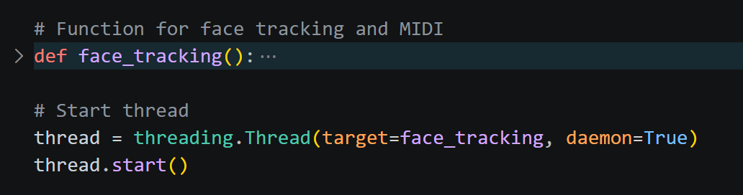

- Working on connecting the wah percentage to the gauge.
- Once again, I have to use a dictionary to store the value of the gauge so that it is mutable.
- It feels like no matter what I do, my timer to update the gauge just can’t reach the updated values, so it always uses the original one I set.

Implementing media queries
- I want the three pages to be put side by side with each other when it is on a wide, desktop screen.
- I will be doing this with Tailwind CSS media queries

- Started by hiding the navigation bar on desktop screens: 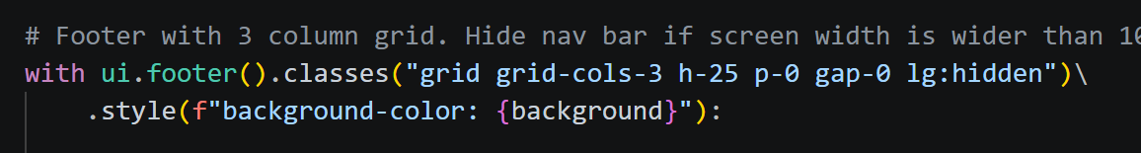

- On mobile screens, the main container will have one column. And on desktop screens, the main container will have three columns for the pages.

- Renders all the pages just once and hide/unhide them to switch. Since the main container has three columns, it will naturally stack side by side when on a desktop screen.
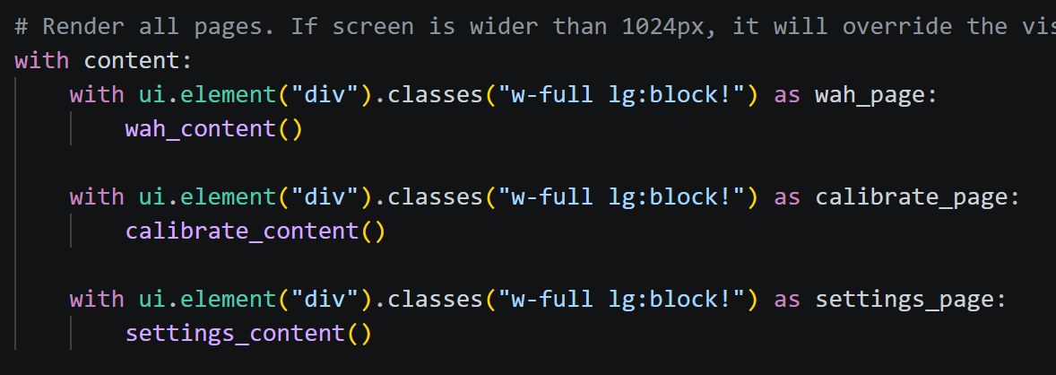
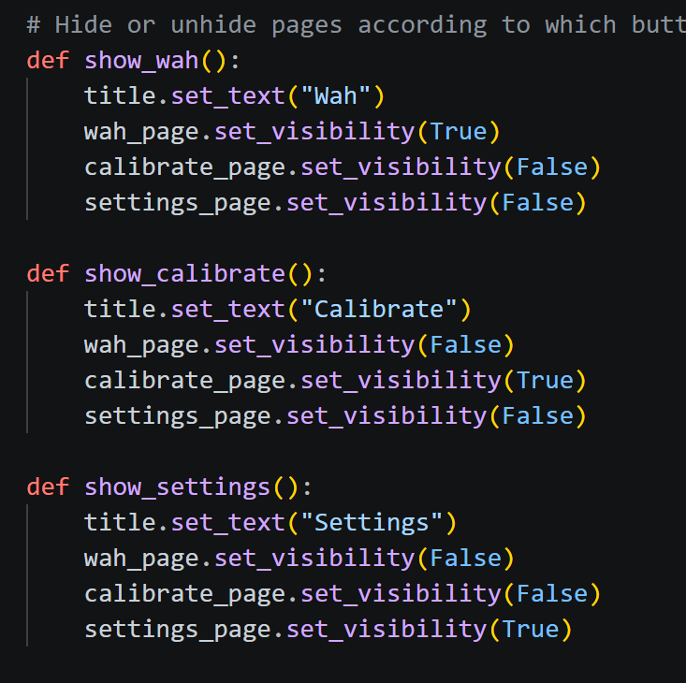
5/09/2026 – Adding a loading screen
NiceGUI has loading icons built in, so I will be using them to create the loading screen.
https://nicegui.io/documentation/spinner
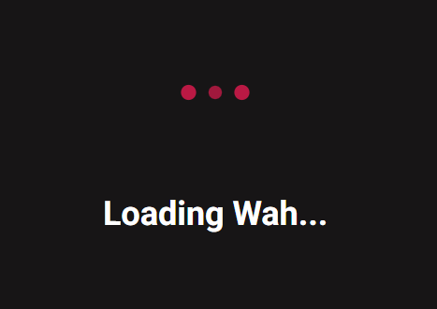
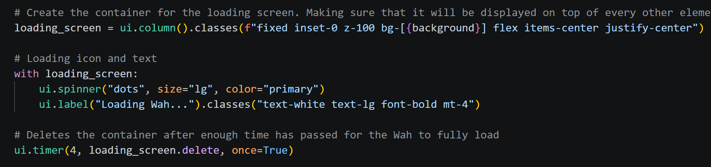
For 4 seconds when the app starts, a loading screen will be shown to allow time for the Wah to initialise.

14/09/2026 – Creating calibration feature
While trying to create the calibration feature, I encountered the same issue where I could not access a changing value inside the thread. This prompted the thought that threading might be the issue, and I’m looking for alternative ways to run the face tracking code in the background.
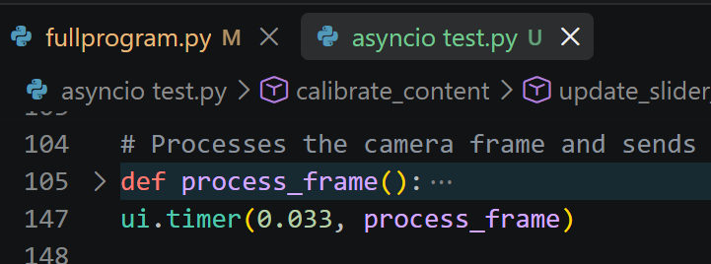
I found something called asyncio that also does what I need. Asyncio is apparently what NiceGUI runs on, so I think there won’t be any issues with values not being accessible in the NiceGUI loop. I may be able to just use a ui.timer line to run the face tracking loop. To test this, I will create a new file.
I removed the while loop that housed the frame processing code and put it in a function so that I could use ui.timer to run it. This did indeed fix all of my issues with accessing values inside of the thread from other functions outside of it.
I can continue to work on the calibration feature.
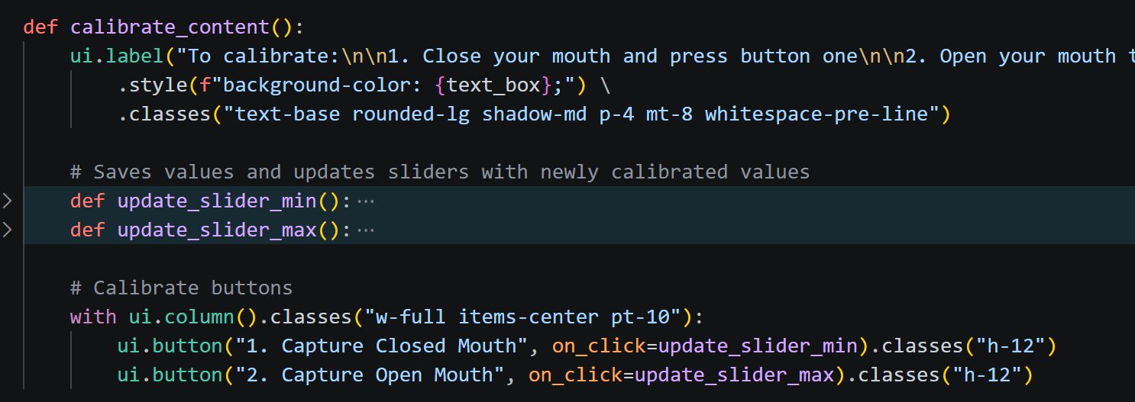
I have changed my mind and I will not be using icons for the navigation bar.

Feedback
12/08/2026
Peer 1:
Received feedback on my usability (visibility of system status).
- Mentioned that it was difficult to know when the program had finished loading.
- Suggested that I may want to add a loading screen on the initial open of the app.
- I will implement a loading screen on launch, so that there is time for the app to initialise.

NiceGUI has loading icons built in, so I will be using them to create the loading screen.
https://nicegui.io/documentation/spinner
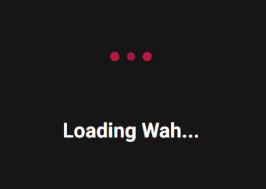
For 4 seconds when the app starts, a loading screen will be shown to allow time for the Wah to initialise.

Peer 2:
Received feedback on my usability (aesthetics).
- I showed her 4 different colour schemes, she initially suggested that I should use a cool-blue scheme.
- I told her about the modern aesthetic I was aiming to achieve, and she agreed that my current scheme was suitable.
- I will keep my current colour scheme

Peer 3:
Received feedback on my usability (help and documentation)
- Complained that he didn’t understand what the settings sliders actually did.
- I will add a short explanation to the calibration and settings page to make sure the user knows how to use them and what they do.
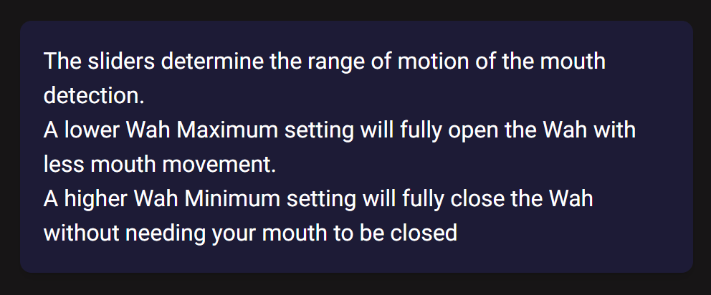

Testing

General Code
Date: 31/08/2026
What’s being tested: Error handling. Running the program without a settings file should not throw any errors. Instead, a settings file with default values should be created.
Pass/Fail: Fail, running the program without the settings file throws an error.
Changes made:
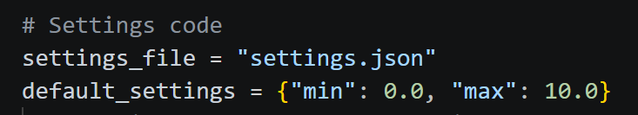
Removed the hardcoded default values, put them in a dictionary for ease of editing.
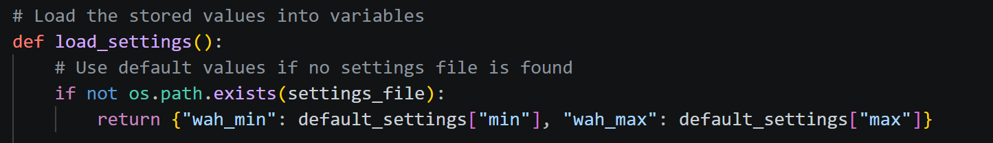
If the settings file is not found during loading, it will return the default values for the sliders to use instead of crashing the program.

Date: 31/08/2026
What’s being tested: Expected output when settings sliders are dragged. Releasing the slide should immediately update the value of the setting in the settings.json file.
Pass/Fail: Pass, the value is updated on release.
Changes made: No changes needed

MIDI and Face Tracking
Date: 13/08/2026
What’s being tested: Testing that Python is sending MIDI commands as expected. This is a core function of the webapp, so it is important to make sure it works as smoothly as possible.
Pass/Fail: Fail, the MIDI commands are sent but there is something causing it to have excessive latency between the mouth moving and the MIDI changing.
Changes made:
The issue was caused by the location of the line which opens the MIDI port. Originally, it was under a loop which made it reopen every frame. This introduces extra lag which caused the latency.
I fixed it by opening the MIDI port before the face tracking loop, so that it only does it once. The MIDI commands are now a lot more responsive than before.
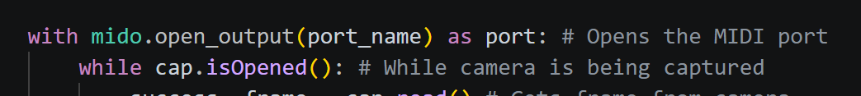

Date: 31/08/2026
What’s being tested: Error handling. Program should not crash or throw errors when there is no MIDI port.
Pass/Fail: Fail, program throws an error when ran without a MIDI port open. Also bad visibility of system status since user is not shown any notification,
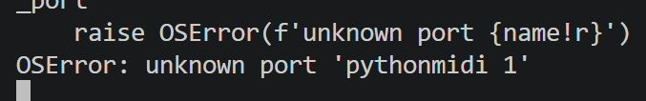
Changes made:
Implemented an error notification that appears if no MIDI port is dected.
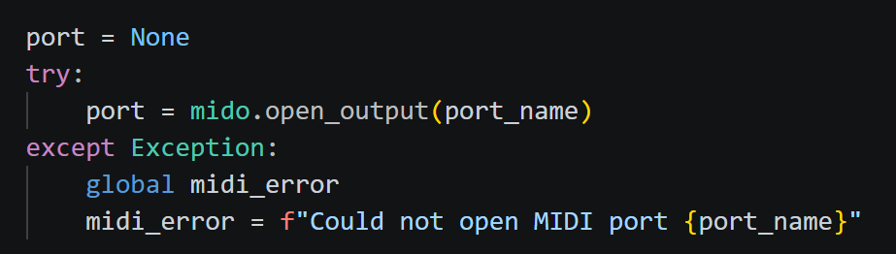

Date: 31/08/2026
What’s being tested: Error handling. When MIDI port closes while the app is running, app should not crash or throw errors.
Pass/Fail: Fail, although I had already implemented code to handle no MIDI port on startup, the program will still throw errors when the port is closed while it is running.
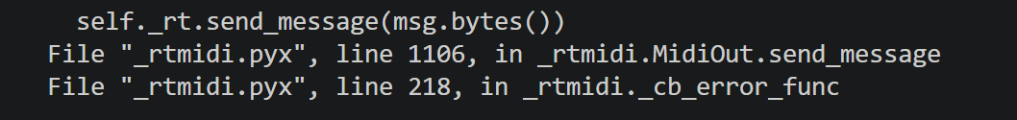
Changes made: Prior to this fix, the program only checked for the missing MIDI port error once on launch. Now, a loop runs every second to check whether the messages are being sent successfully. 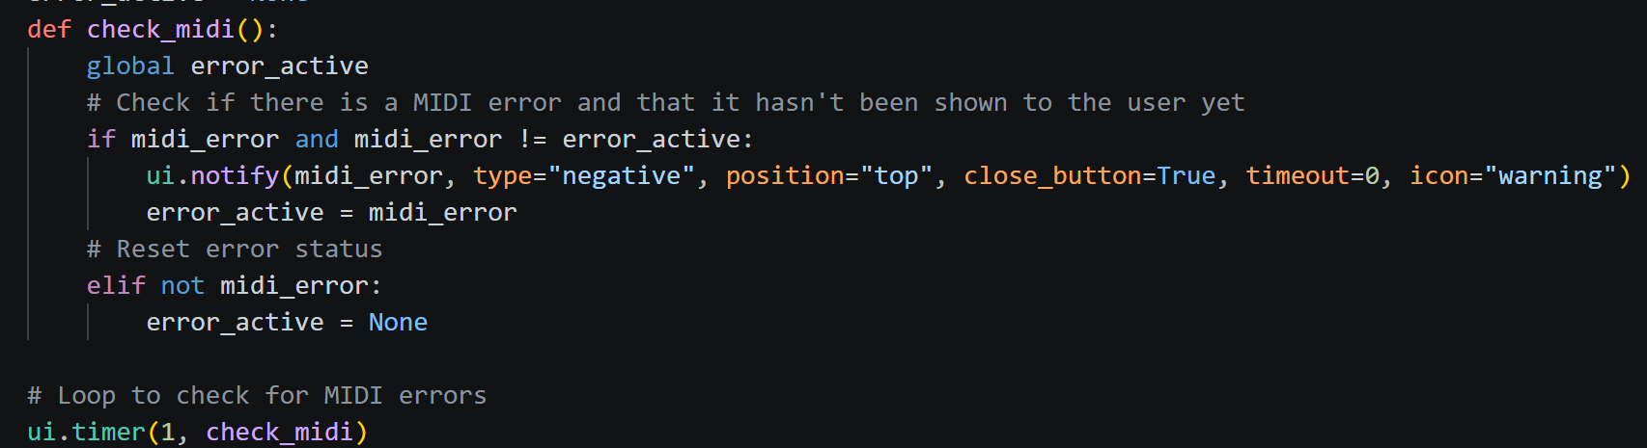

Web UI
Date: 20/08/2026
What’s being tested: Mobile users are able to switch tabs smoothly
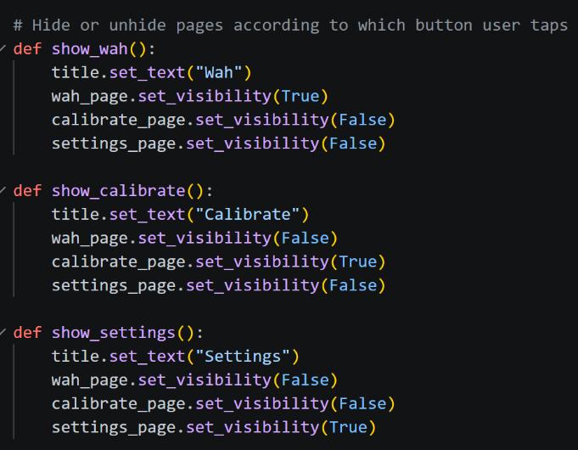
Pass/Fail: Fail. Switching tabs causes the MIDI to freeze briefly. I believe this is due to the need for NiceGUI to redraw the page every time a new page is opened.
Changes made: Made the program draw all three pages from the beginning. Then hiding and unhiding them according to which tab is open (as seen in the picture on the right). This means that the program only has to draw the pages once and not every time the user changes tabs.

Date: 31/08/2026
What’s being tested: Expected behaviour from UI elements. Wah gauge on main page should update in time according to the user’s mouth.
Pass/Fail: Fail, gauge does not update because the function that draws the gauge cannot access the updated wah percentage value. This means that the gauge only shows the original value of the shared dictionary.
Changes made: To troubleshoot, I isolated the thread.
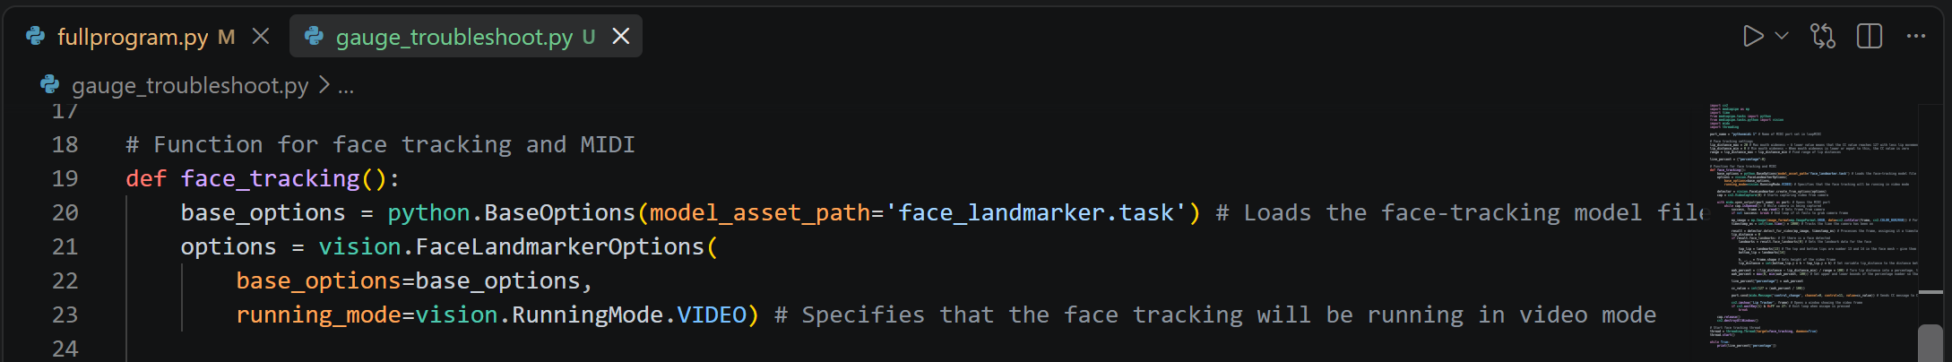
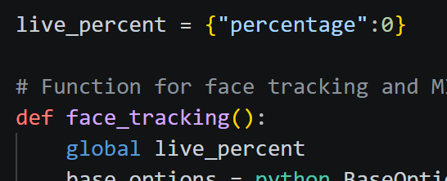
I think it may be a program scope issue, where the thread can’t modify the dictionary for the rest of the program. To test this, I will declare the global scope for the live_percent variable inside of the thread function.
This did not fix the issue.
While testing, I replaced the ui.timer line with a while True loop. This allowed the updated value to be accessed so it has to have something to do with the way NiceGUI works.
10/09/2026
While trying to create the calibration feature, I encountered the same issue where I could not access the changing value inside the thread. This prompted the thought that threading might be the issue, and I’m looking for alternative ways to run the face tracking code in the background.
I found something called asyncio that also does what I need. Asyncio is apparently what NiceGUI runs on, so I think there won’t be any issues with values not being accessible in the NiceGUI loop.I may be able to just use a ui.timer line to run the face tracking loop. To test this, I will create a new file.
I removed the while loop that housed the frame processing code and put it in a function so that I could use ui.timer to run it. This did indeed fix all of my issues with accessing values inside of the thread from other functions outside of it.
With this change, the gauge is fixed, and it updates in real time according to the percentage of the Wah.

Date: 31/08/2026
What’s being tested: Responsive UI design (media queries). The UI should change depending on what screen the user is on. Screens wider than 1024px will be shown a desktop view with all three pages side by side. Whereas mobile screens will be shown a navigation bar and a header.
Pass/Fail: Pass, the program layout changes at my specified breakpoint.
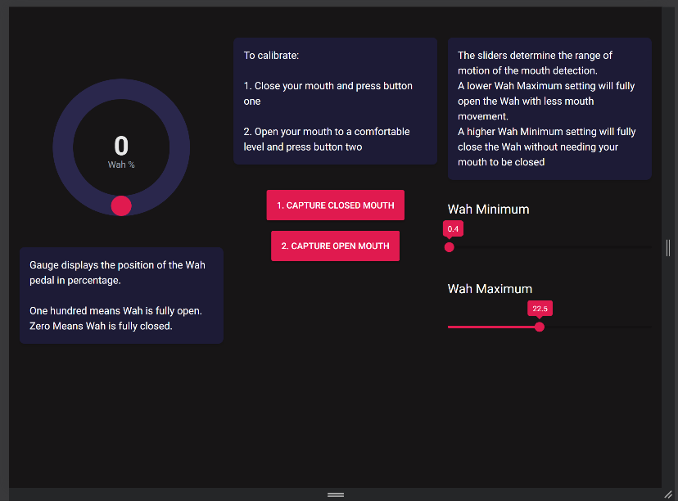
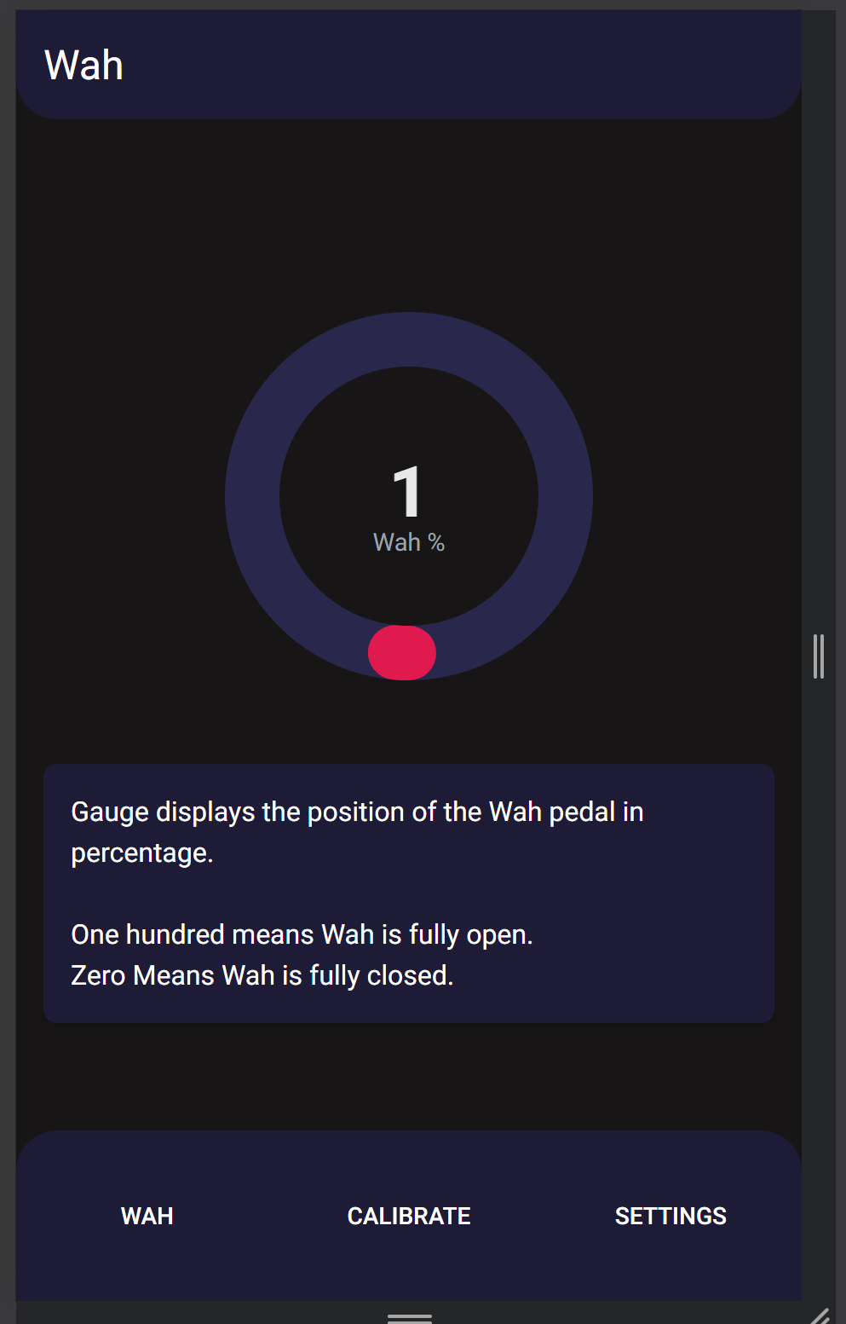
Changes made: No changes needed

Date: 2/09/2026
What’s being tested: Usability aesthetics. Should have good contrast between the background and the text so that text is not hard to read.
Pass/Fail: Fail, contrast is fine in most locations, but the “Close” button on the error notification is too hard to see on the red background.
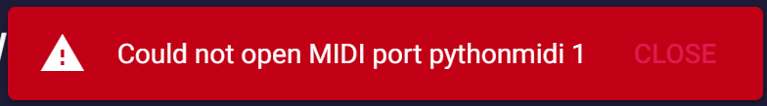
Changes made:
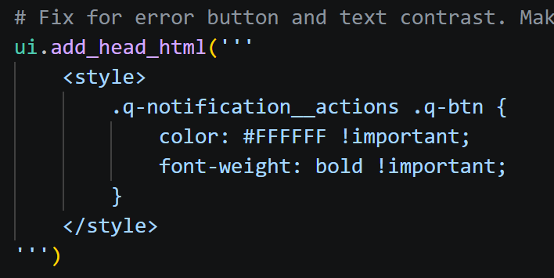
Added custom CSS rules to change the default Quasar notification styling. Makes the “Close” button white and bold to improve contrast.

Date: 21/09/2026
What’s being tested: User’s settings are saved, even after program is restarted.
Pass/Fail: Pass, the settings sliders load the previously saved values from the JSON file on app launch. So the settings are retained across restarts.
Changes made: No changes needed

Date: 21/09/2026
What’s being tested: Visibility of system status. The user should be told when the app is loading.
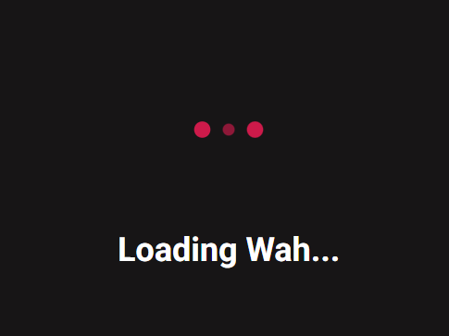
Pass/Fail: Pass, the webapp starts up into a loading screen to allow time for the MIDI to initialise.

Changes made: No changes needed

Date: 21/09/2026
What’s being tested: Visibility of system status. The user should immediately be shown an error notification when the MIDI connection drops out, or a MIDI port was not detected on launch.
Pass/Fail: Pass, a red popup appears telling the user that the port could not be accessed, along with the name of the port.
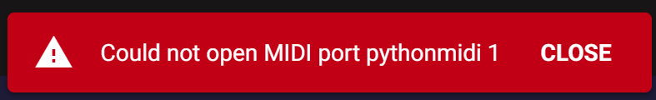
Changes made: No changes needed

Date: 25/09/2026
What’s being tested: Boundary values, lower and upper bounds for the settings of the Wah should be 0 and 50 respectively.
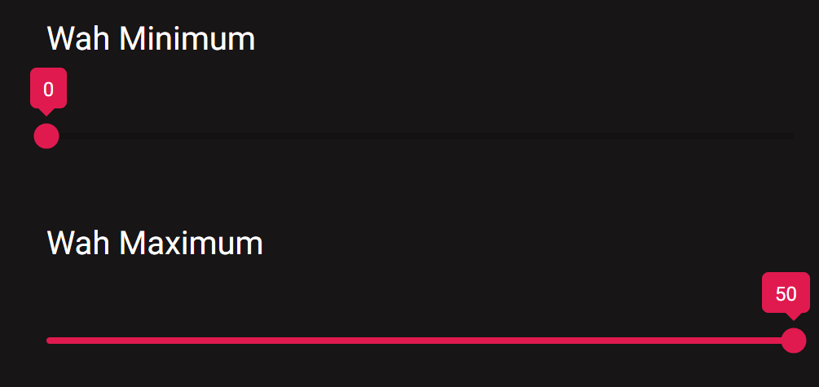
Pass/Fail: Pass, the settings cap out at those values.
Changes made: No changes needed

Date: 26/09/2026
What’s being tested: Visibility of system status. The user should be given clear visual feedback for any of their actions.
Pass/Fail: Fail, when the user clicks the calibrate button, nothing shows the user that the calibration has successfully been applied.
Changes made:
Added a notification popup that tells the user when their calibration has gone through.
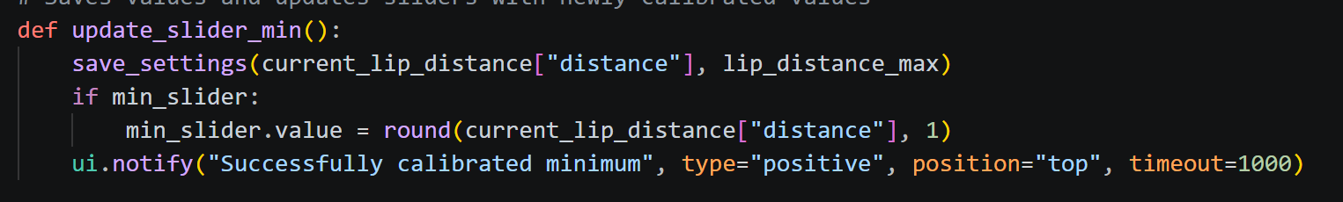
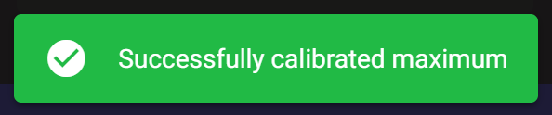

Reflection
Throughout the development of my outcome, testing and user feedback were used to improve my webapp. Testing included making sure the program was robust, and that the UI followed good usability heuristics. It revealed bugs relating to JSON file handling, Python MIDI, and elements of my responsive UI.
These issues included but were not limited to:
- Errors when program is run without JSON settings file.
- MIDI latency that makes the program practically unusable.
- A gauge that did not move.
I also tested for aesthetics and usability, which helped me ensure vital parts of my UI such as media queries and the navigation bar worked in the intended way. As well as helping me realise issues I had regarding low contrast text.
For example, I discovered and fixed issues to do with:
- Optimisation of the outcome. Testing revealed that my original way of switching pages was inefficient and introduced lag.
- Aesthetics. I found some parts of the program such as the error notification difficult to read.
User feedback offered to me revealed my lack of help and documentation for the user, and the visibility of system status. I added a loading screen and instructions for each part of the program in response to this, so future users can have a better experience.

Advanced Techniques
- Media queries – The layout of the web app will change depending on what device is using it. Desktops with a wide, horizontal screen will have all of the pages side-by-side on one page. Whereas people using phones will be shown a navigation bar on the bottom leading to each page.

Media queries were used in these locations:
  - Using Tailwind media queries in combination with CSS grid. ‘lg’ means when the screen is 1024px or wider. The webapp will change to a 3 column layout past this breakpoint.
  - Hides header past the 1024px breakpoint so desktop users do not see it.
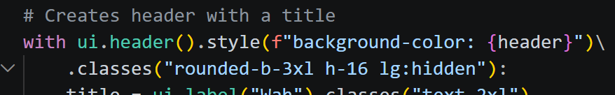
  - Overrides the layout for mobile and displays all pages at once when the user is on a screen wider than 1024px.
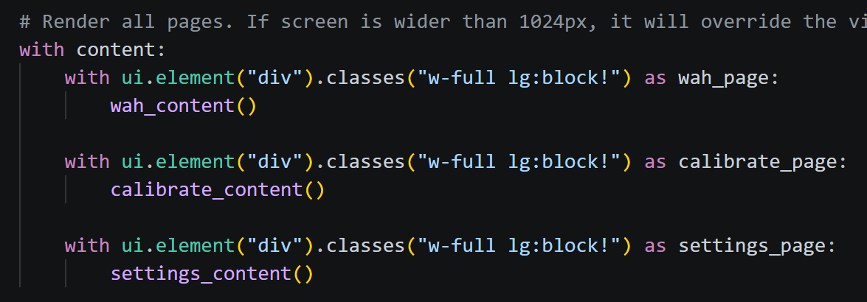
  - Hides footer past the breakpoint since desktop users do not need it.

- JSON data files – Settings for the webapp will be saved in a JSON file so that they stay the same after closing the app. Each time the user changes a setting, it’s new value will be written to the JSON file.

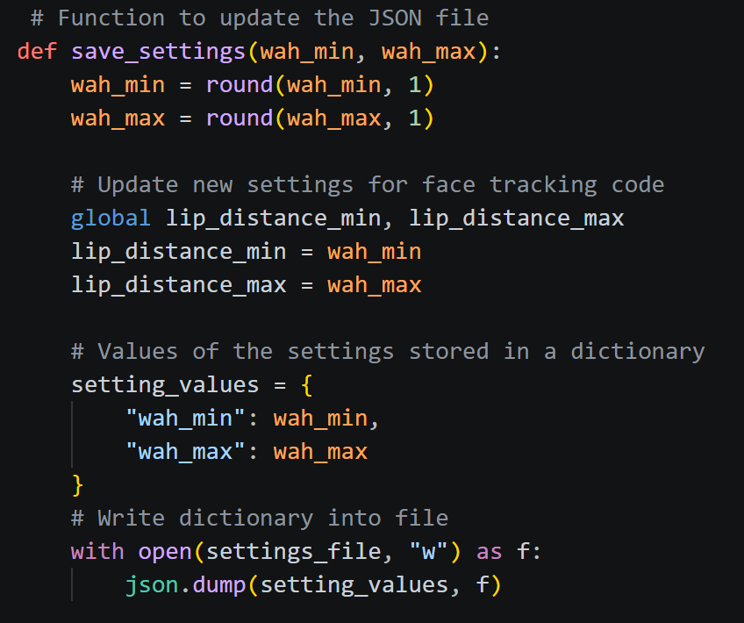
  - Function is called with the new values when settings sliders are changed and when the calibration buttons are clicked. This saves the values to a JSON file.

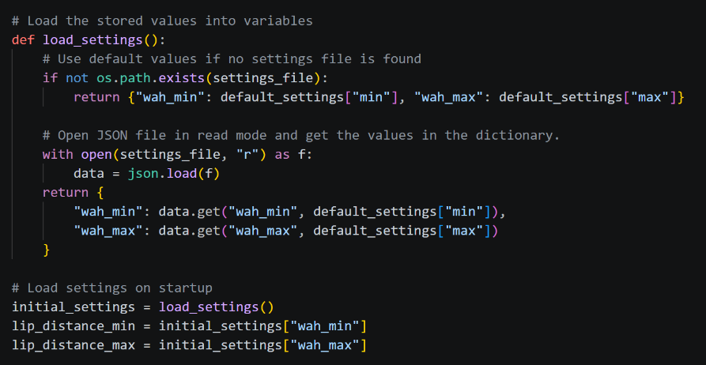
  - Loads the previously saved settings on startup. Includes error prevention for when there is no JSON file found, it will fall back to default values that that be set using a dictionary.

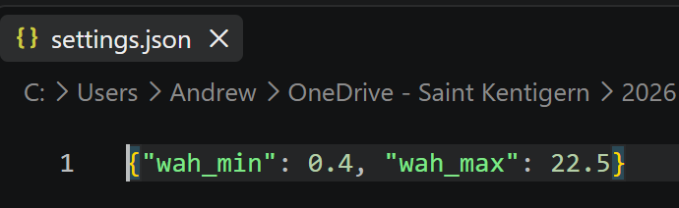
  - Screenshot of the saved settings in the settings file:

- CSS Grid – Used to create identically sized buttons in the navigation bar which scale according to the screen width. Also used to display everything on one screen, side-by-side on a desktop screen.
  - Uses CSS Grid to lock the web page layout to either one column, or three columns side by side depending on the user’s screen width.

  - Uses CSS Grid to create three evenly sized buttons on the navigation bar.
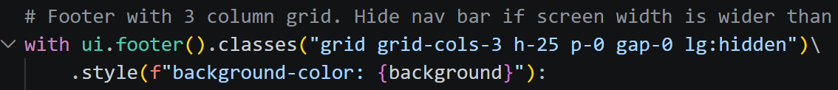

Project Management Tools
Notion is used as a task checklist to track due dates and what tasks need to be prioritised. My Notion is set up in a table layout with due dates, start dates, finish dates, and a priority for the task. This makes it easier for me to plan my time efficiently since all of my tasks are laid out in a simple, comprehensible format.
My sprints are organised using the due dates on my Notion, they are in groups of 4 or so tasks per date, and they show the tasks I aim to complete for that specific period of time. Using this format ensured that I could fully complete my outcome in an organised, non-rushed manner.
An issue I had was that after I delayed fixing the gauge during the August 21st sprint, it caused me to miss tasks in the following sprint because the broken part of the gauge was required for my calibration feature. Next time, it would be better to focus on the tasks that I have labelled as high priority, so that I don’t encounter any issues like these.
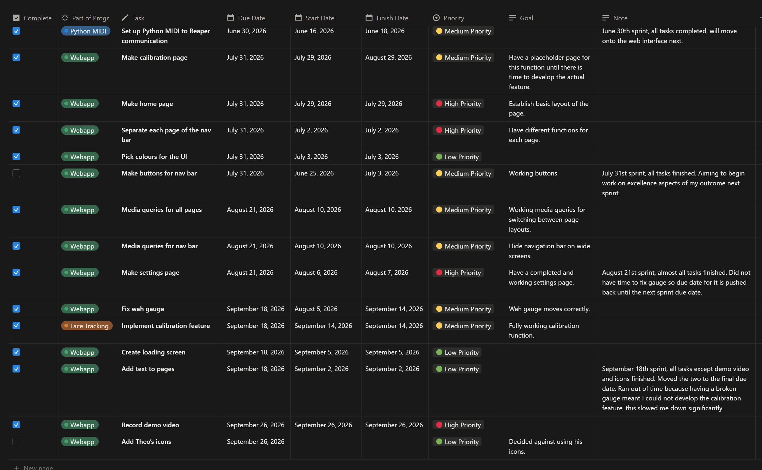

Github is used for version control. I push versions of my program to Github before making big changes or after having made changes. This gives me a backup of all my work that I can revert to in case anything goes wrong.
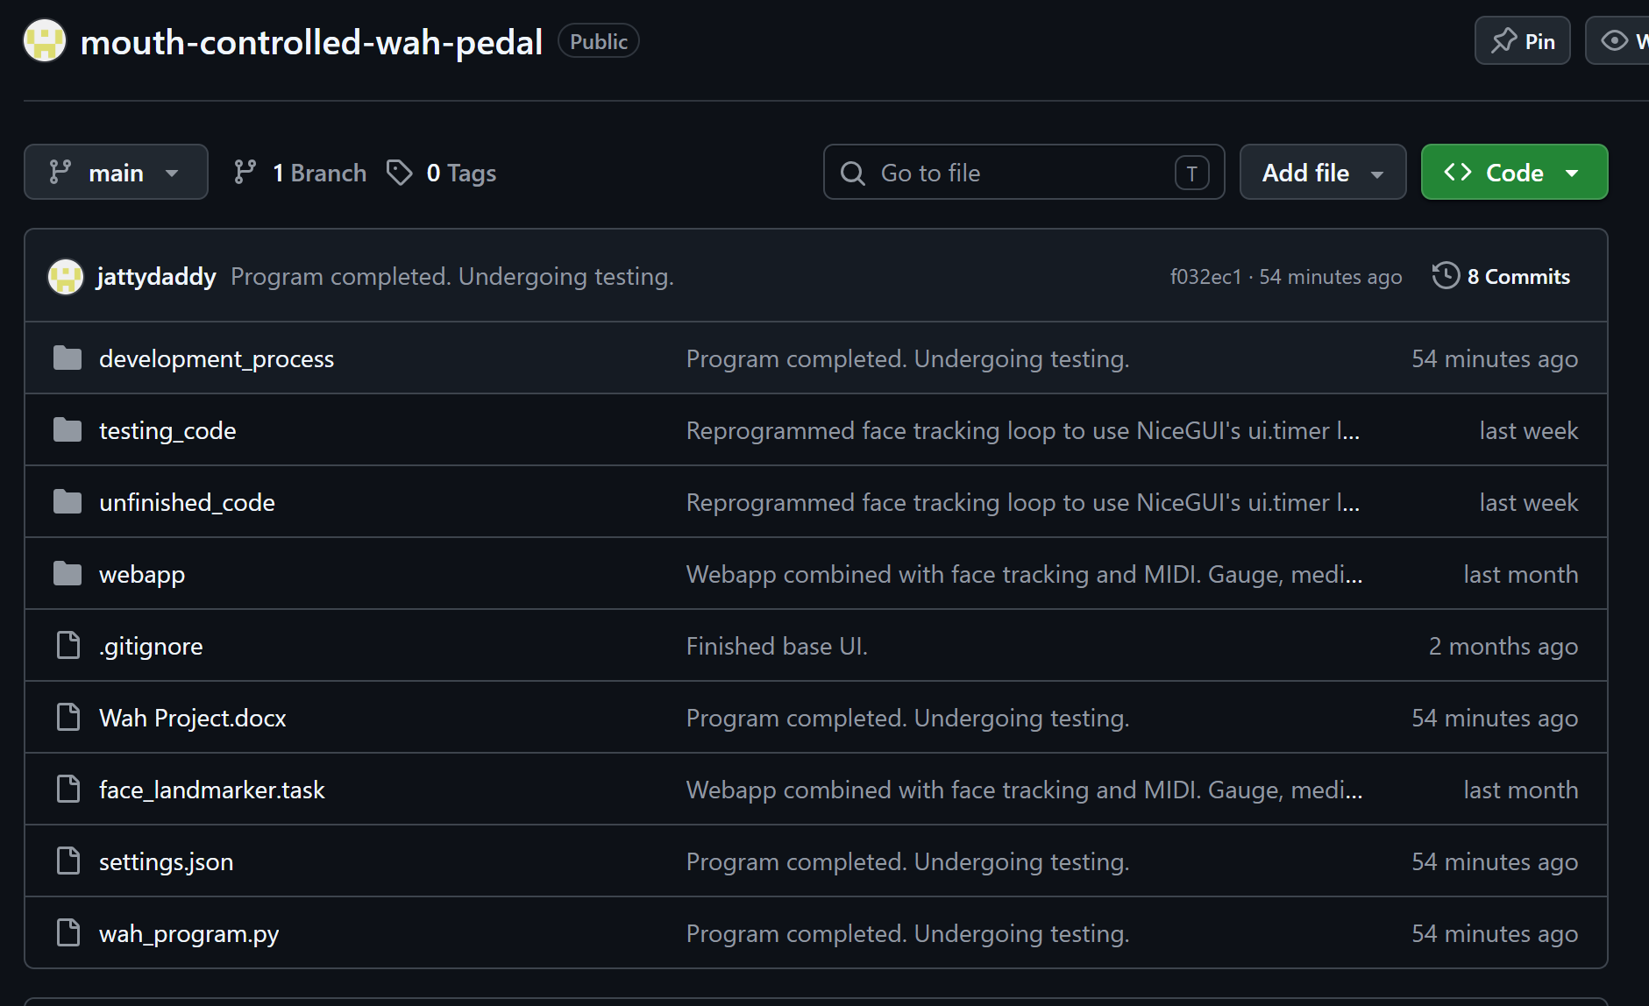
A snippet of the history for the webapp:
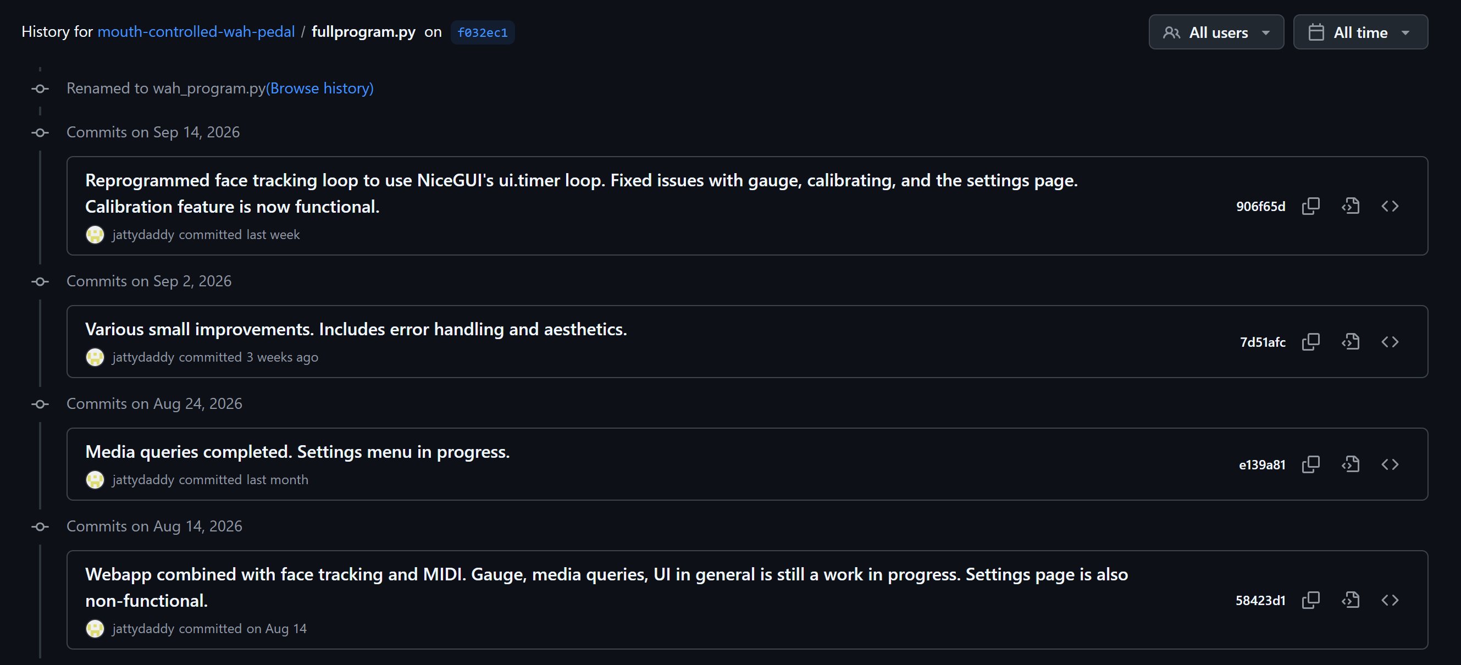
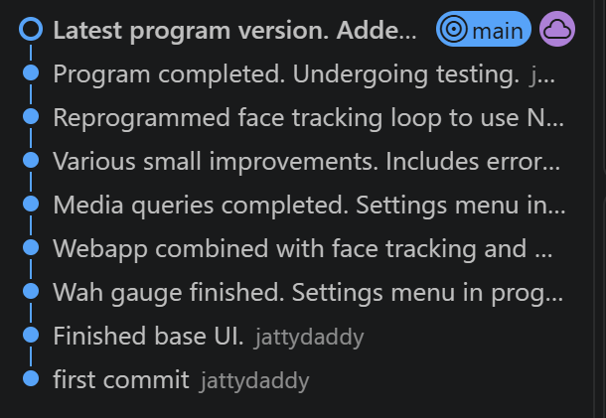

Implications
Privacy
My app uses live video from the user’s camera to track their face using Mediapipe. This means that it is important to consider the privacy of the user. I must ensure that the app does not store or share any information such as photos, videos, or audio of the user. To address this, all data from the user’s camera is processed locally in the memory of the user’s device, so each frame is discarded after the lip distance has been calculated. Additionally, the only data saved are the “Wah minimum” and “Wah maximum” settings, stored inside a JSON file. These are two numerical values that do not hold any personal information about the user.

Usability
This outcome is intended for guitar users. It allows them to control a guitar wah pedal with their face. This means that I must ensure that the UI is responsive and intuitive since the user will need to operate it while playing guitar. To achieve good usability, my outcome features an SVG percentage gauge that updates in real time, a responsive layout that changes between one and three pages depending on the size of the user’s screen, and notification popups that tell the user about system status. The SVG gauge gives the user immediate feedback on their mouth position, while the responsive layout ensures that the user will see a usable UI no matter what kind of device they are on. The notification popups alert the user about when errors occur, including what error it was, so that the user knows exactly what is happening.

